From the 10 teachers who went to the Turkish mobility and answered the form 3 are French, 2 Spanish, 3 Turkish and 3 Portuguese.

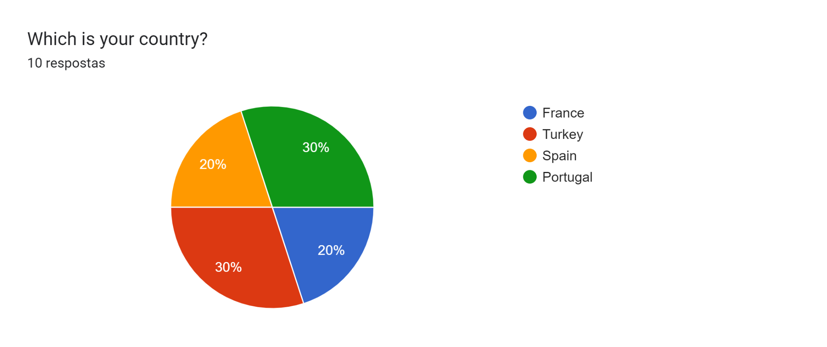

**Activities mobility**

**What was the most challenging in this mobility?**

The three most challenging aspects in this mobility were related to language barrier, time management and managing teenagers. On the one hand, the teachers considered that it was difficult to make some of the students speak English which somehow didn’t allow them to interact with each other as much as it was expected. On the other hand, some found it difficult to manage the time of the activities, having it done as it was planned all the time. Lastly, managing teenagers was an unexpected challenge for the Portuguese teachers especially, since their students didn’t behave the way they were supposed to.

**How did you overcome it?**

Most of the teachers considered that having a positive attitude was the most important to overcome some of the situations. Patience and a lot of conversation were needed as well as the help of all the teachers connected to the project to overcome some situations with the students. As far as the time management was concerned punctuality seemed to be the key to the problem. Lastly, in what concerns the communication issue some teachers believed that the use of more real and more guided interactive activities could be helpful.

Before the mobility the teachers had access to the plan with the activities developed on the Turkish mobility. Most of the teachers considered that the objectives planned before the mobility were clearly identified. 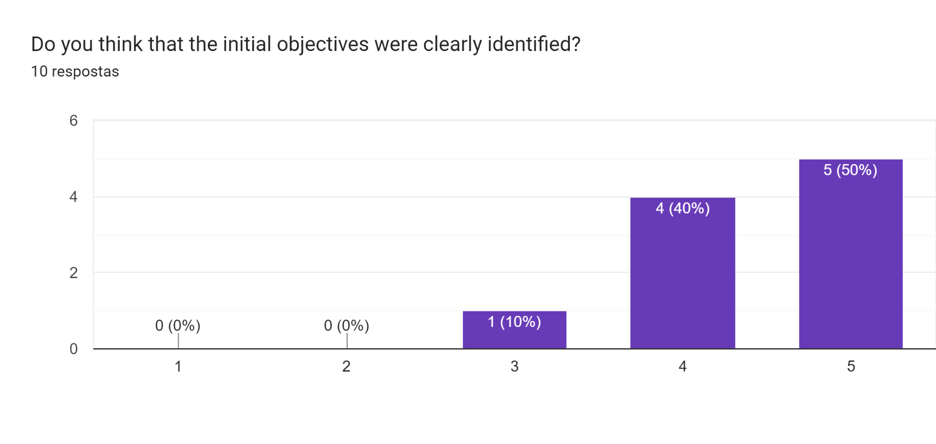

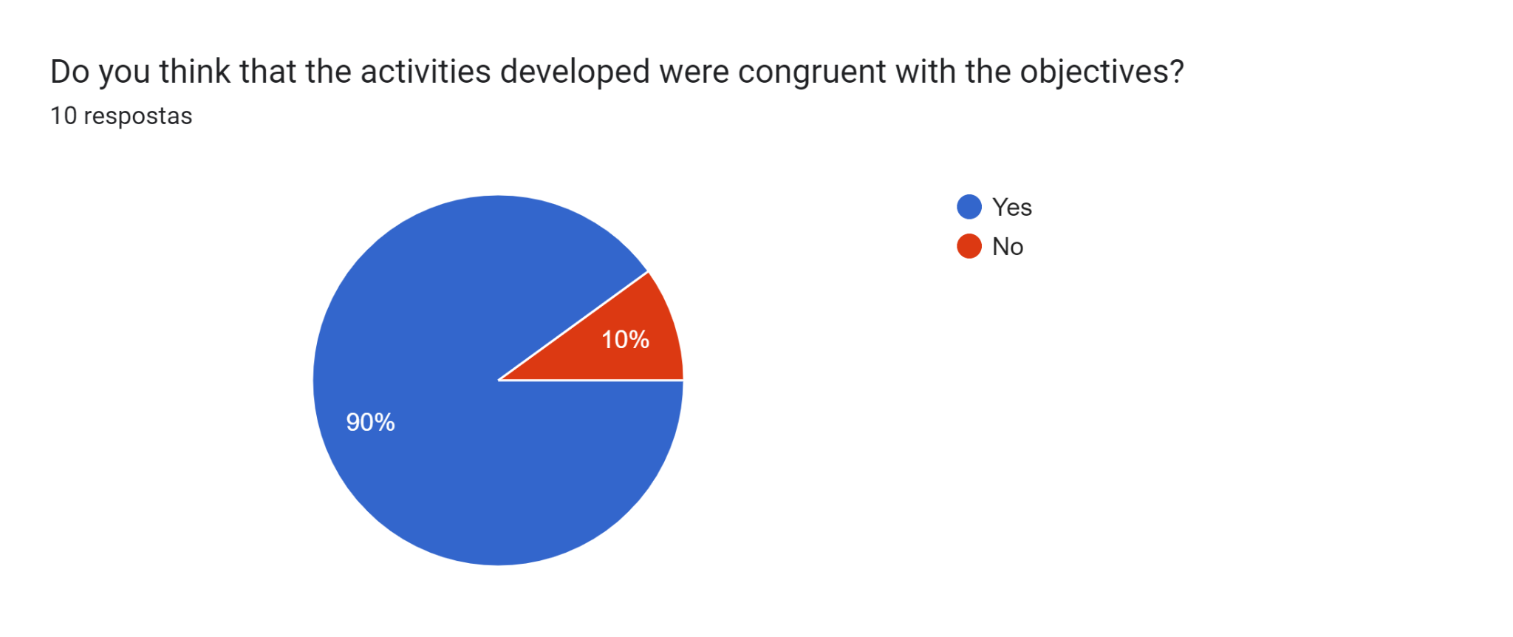

According to the objectives outlined in the plan, only one teacher taught that the activities developed during the mobility were according to the objectives.

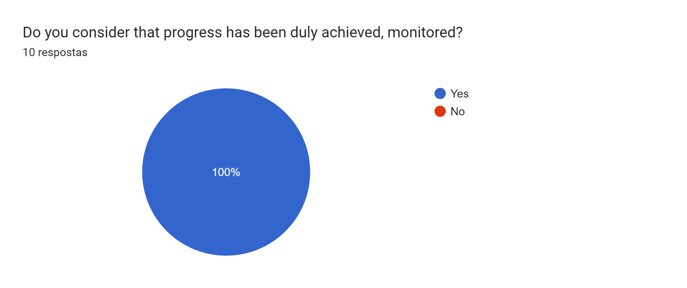

All of the teachers considered that progress has been achieved and monitored.

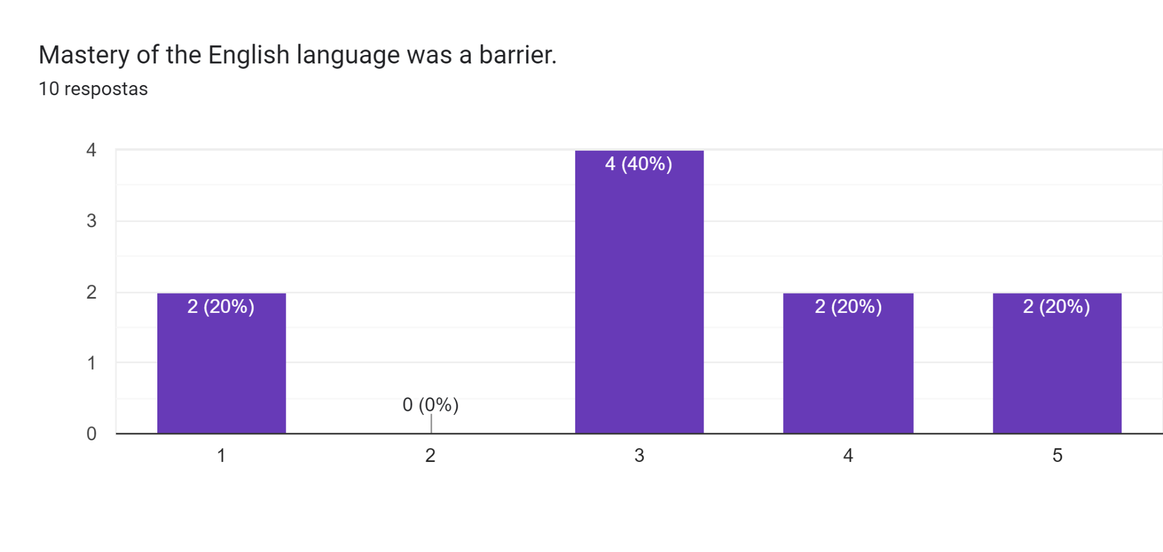

Most of the teachers believed that the mastery of the English language was a barrier to the development of activities and interpersonal relationships. Besides, it was a barrier to the autonomy of the students and to the relationship between them.

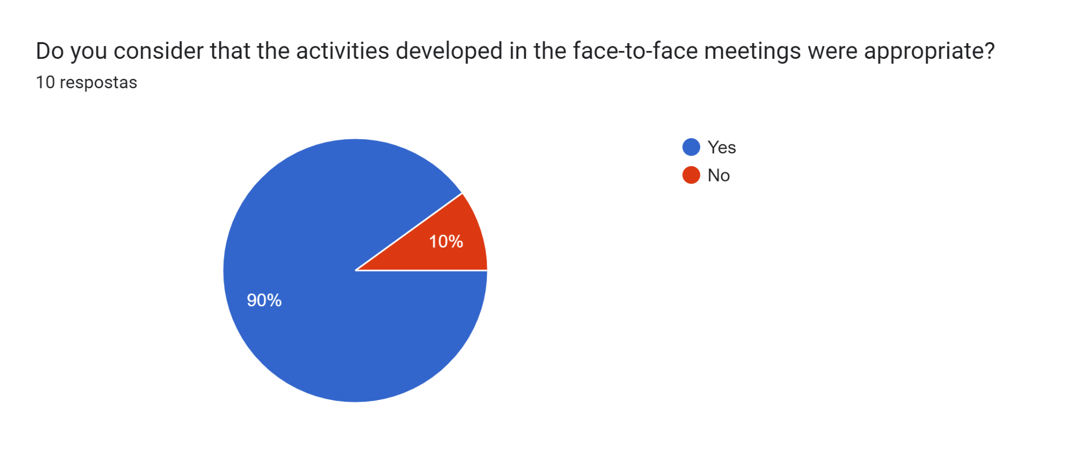

Only 1 of the teachers didn’t consider that the activities were appropriate.

**Name the best pedagogical activity.**

All things considered the entrepreneur video workshop was the best pedagogical activity for most of the teachers. Some also highlighted the visit to the enterprise, the poster design and the students' presentation.

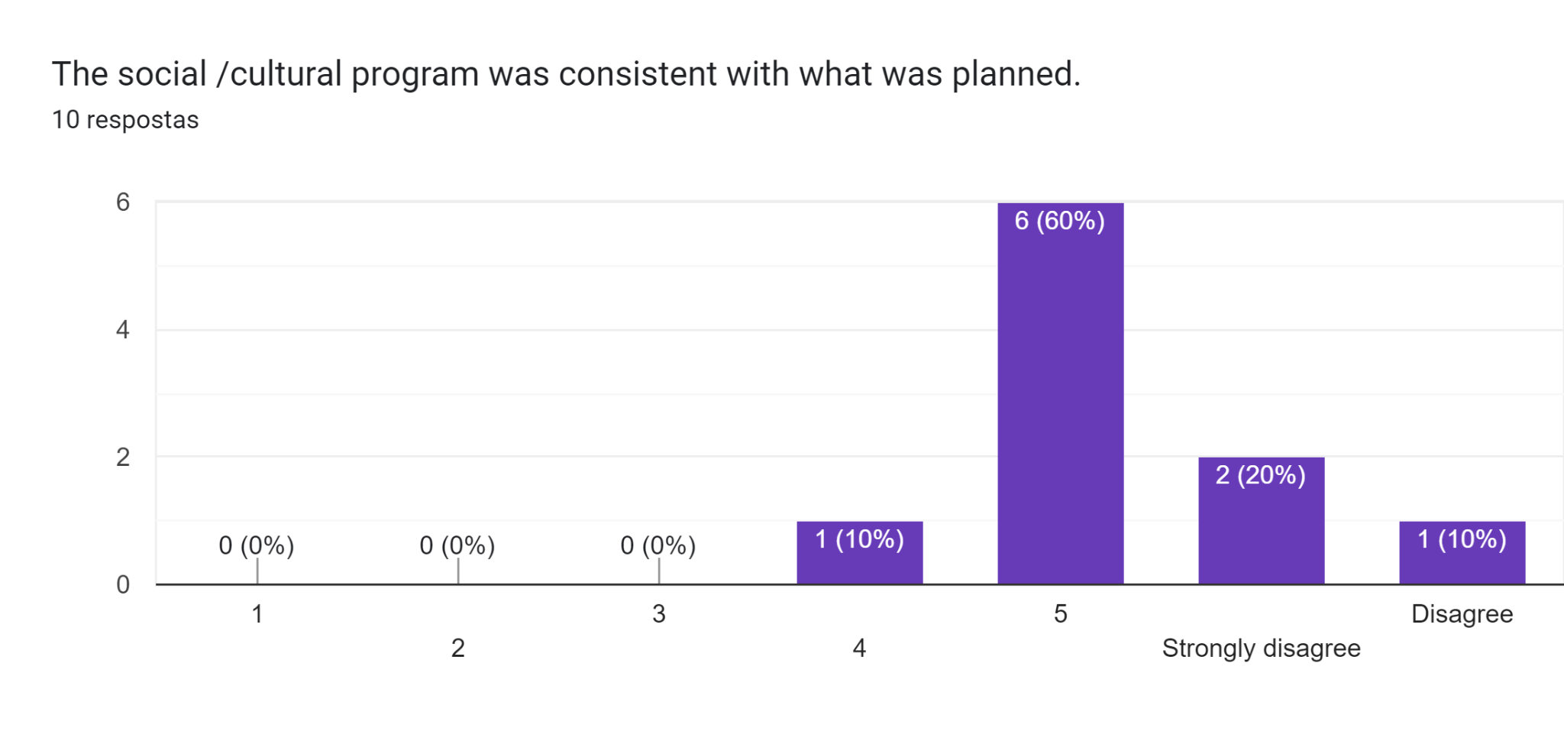

6 teachers considered the social/cultural program consistent with what was planned. 3 of the teachers didn’t agree with that statement.

**Name the best cultural activity.**

The best cultural activity was undoubtedly the cultural day on the first day in Turkey, with the visit to the city, the several mosques and the Bosphorus Tour.

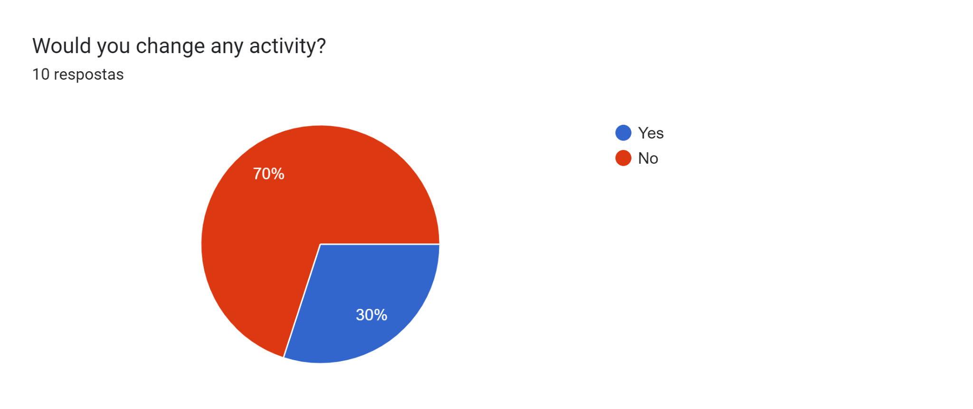

Most of the students didn’t consider to change any activity.

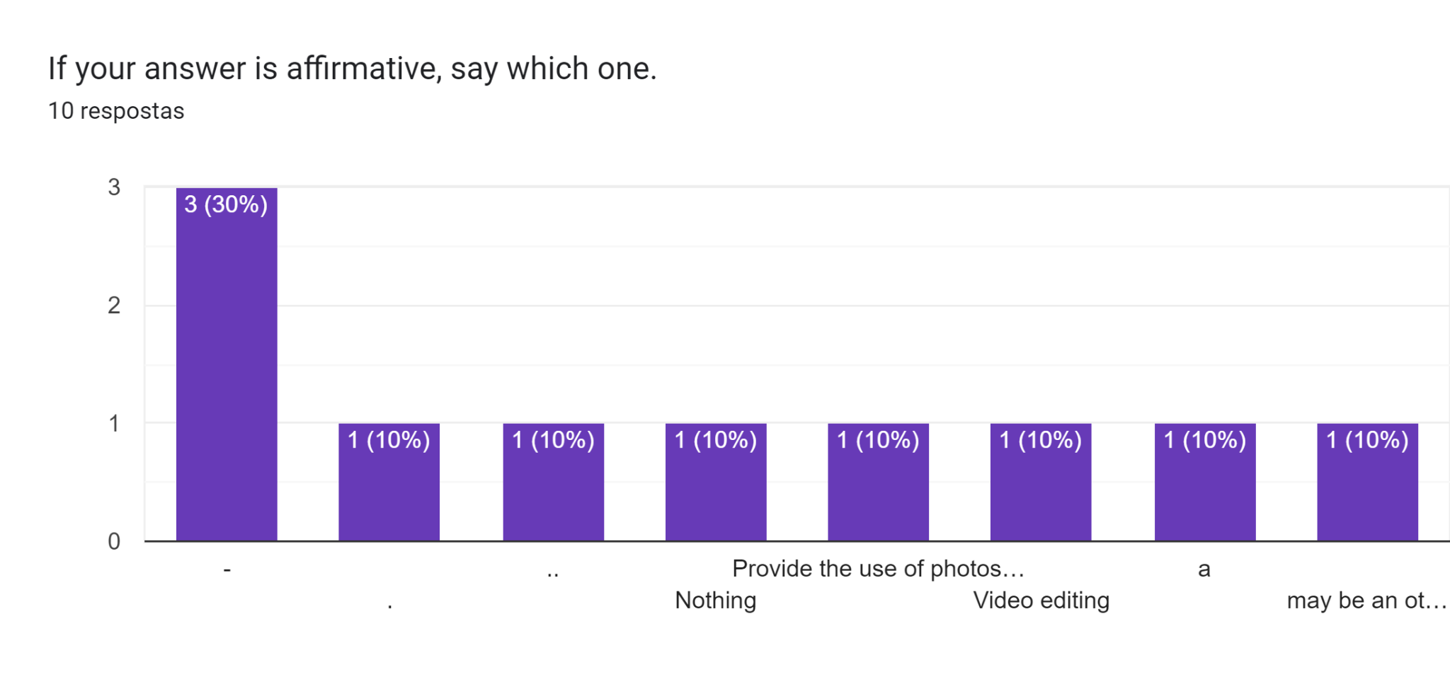

One of the teachers said they would provide photoshop to more students. The other one would change video editing activity and the last one wanted to visit another company during the Turkish mobility.

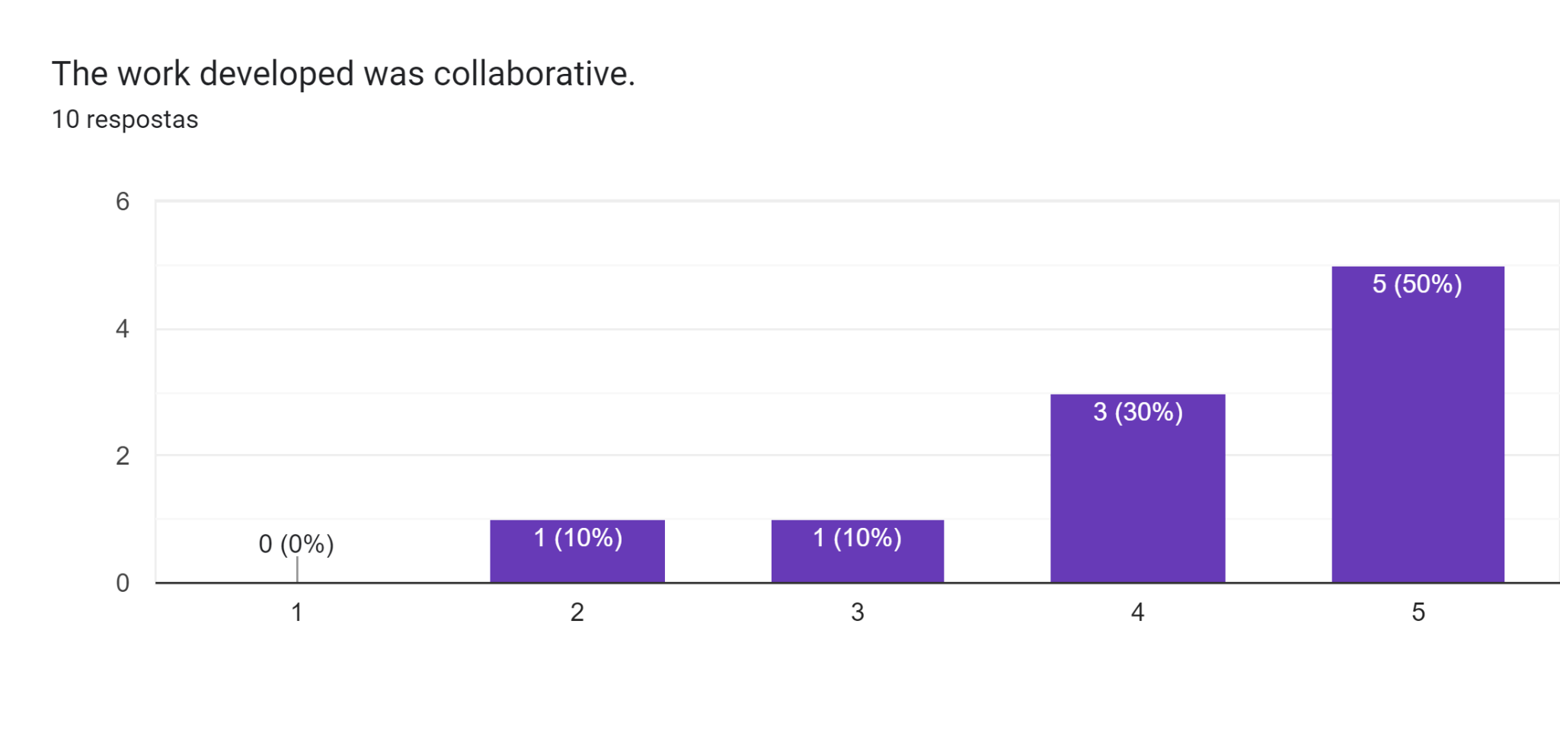

Most of the teachers believed that the work developed during the activities was collaborative. Only one teacher considered that there was no collaborative work.

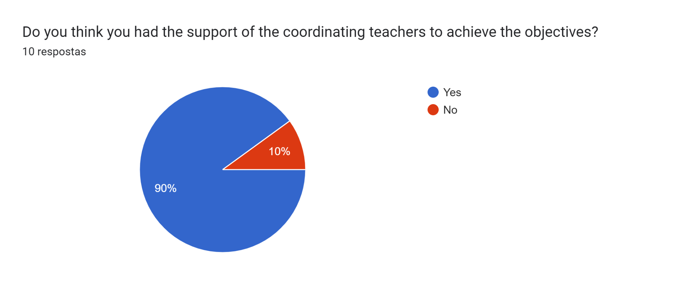

During the activity, we had the support of the coordinating teachers to achieve the objectives. Only one teacher considered the opposite.

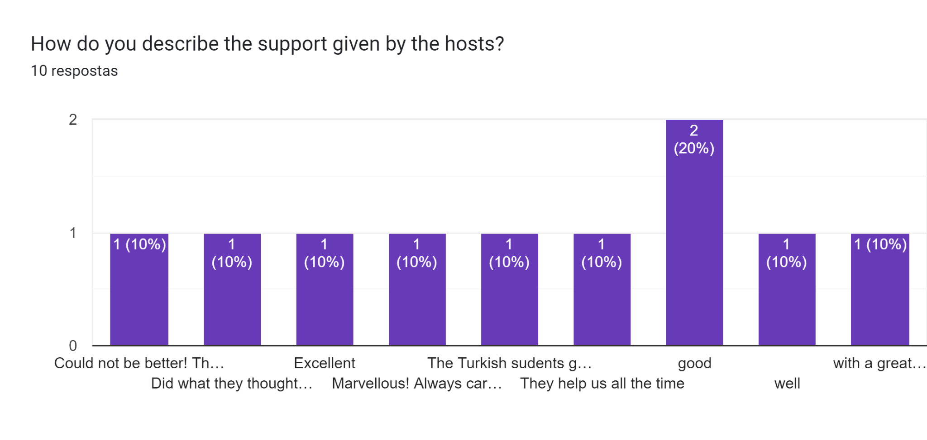

Generally the teachers considered that all the hosts from teachers to students were really supportive, careful and attentive. Everyone felt positive and concerned with the others' well-being. Nobody felt insecure or lost in such a big city as Istanbul.

**Pos mobility**

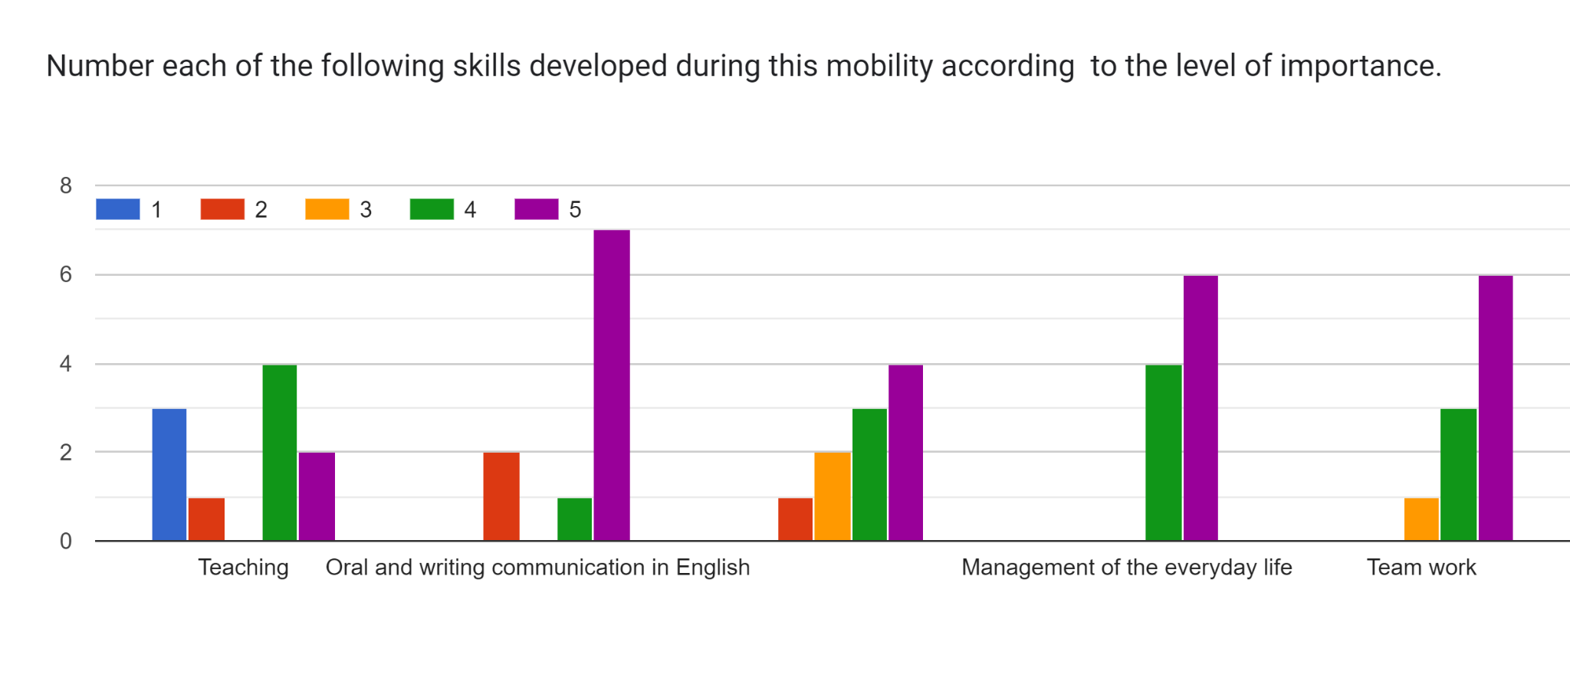

In the teacher's opinion the most important skills developed during this mobility were oral and written communication in English; Management of everyday life and teamwork.