From the 35 students who went to the Turkish mobility and answered the form 7 are French, 9 Spanish, 12 Turkish and 7 Portuguese.

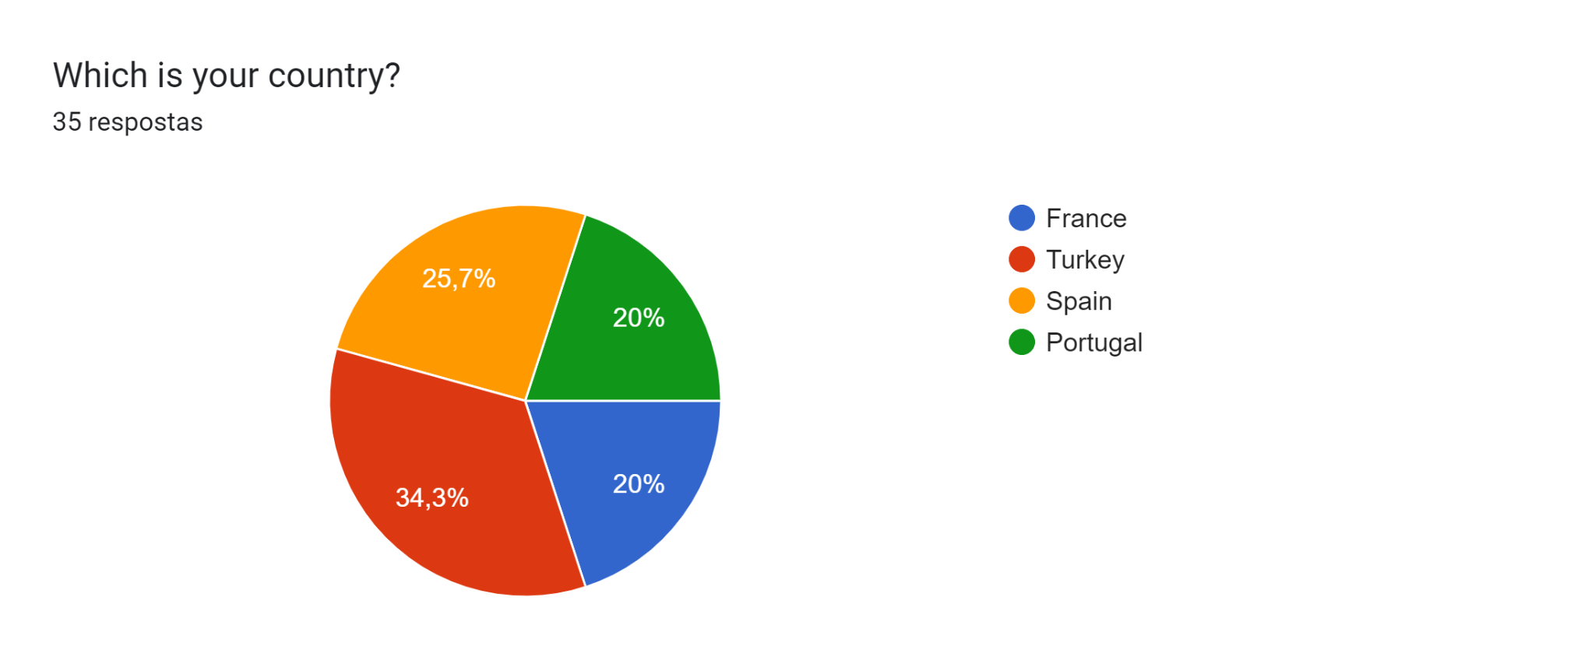

**Pre mobility**

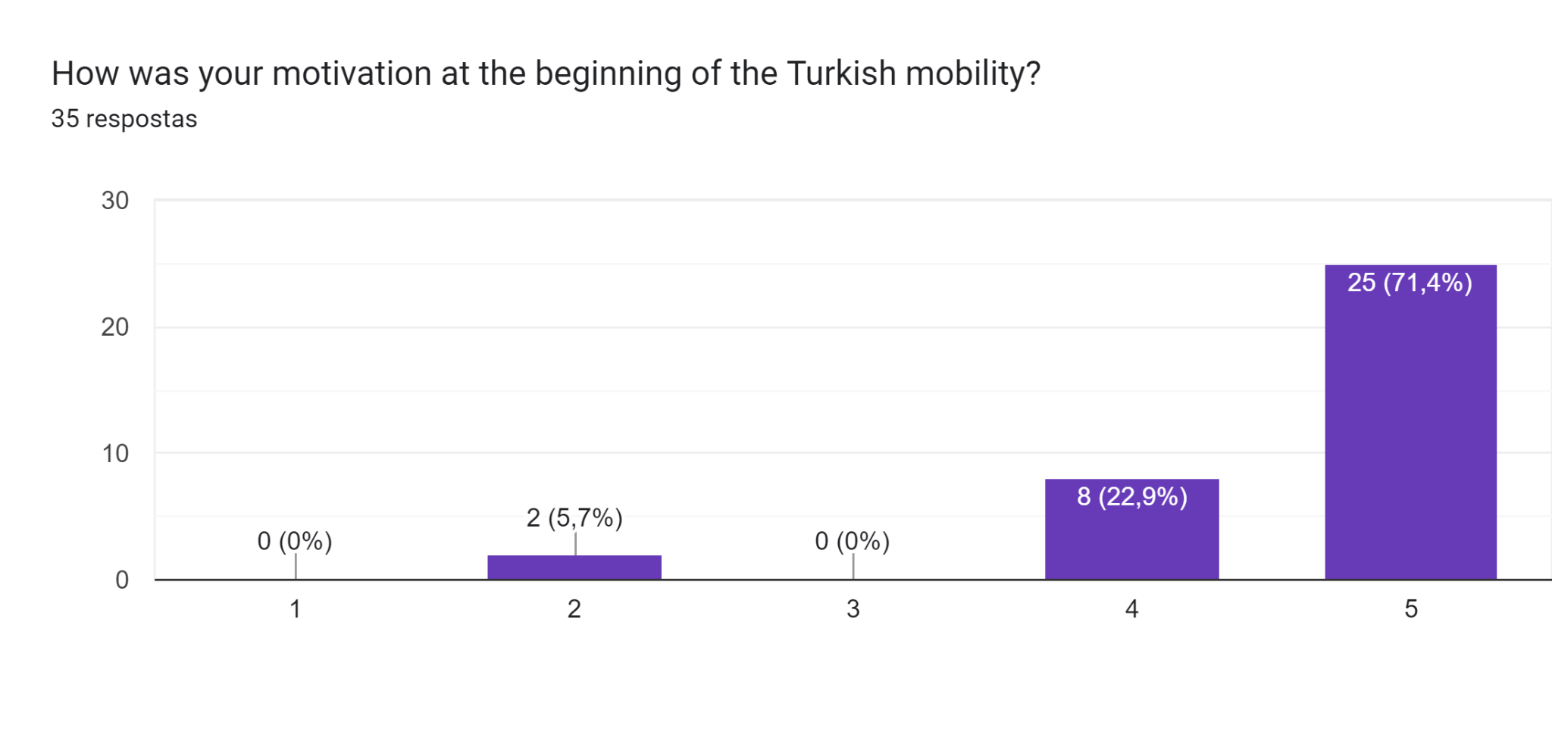

Most of the students were very motivated at the beginning of theTurkish mobility. Only two students weren't motivated.

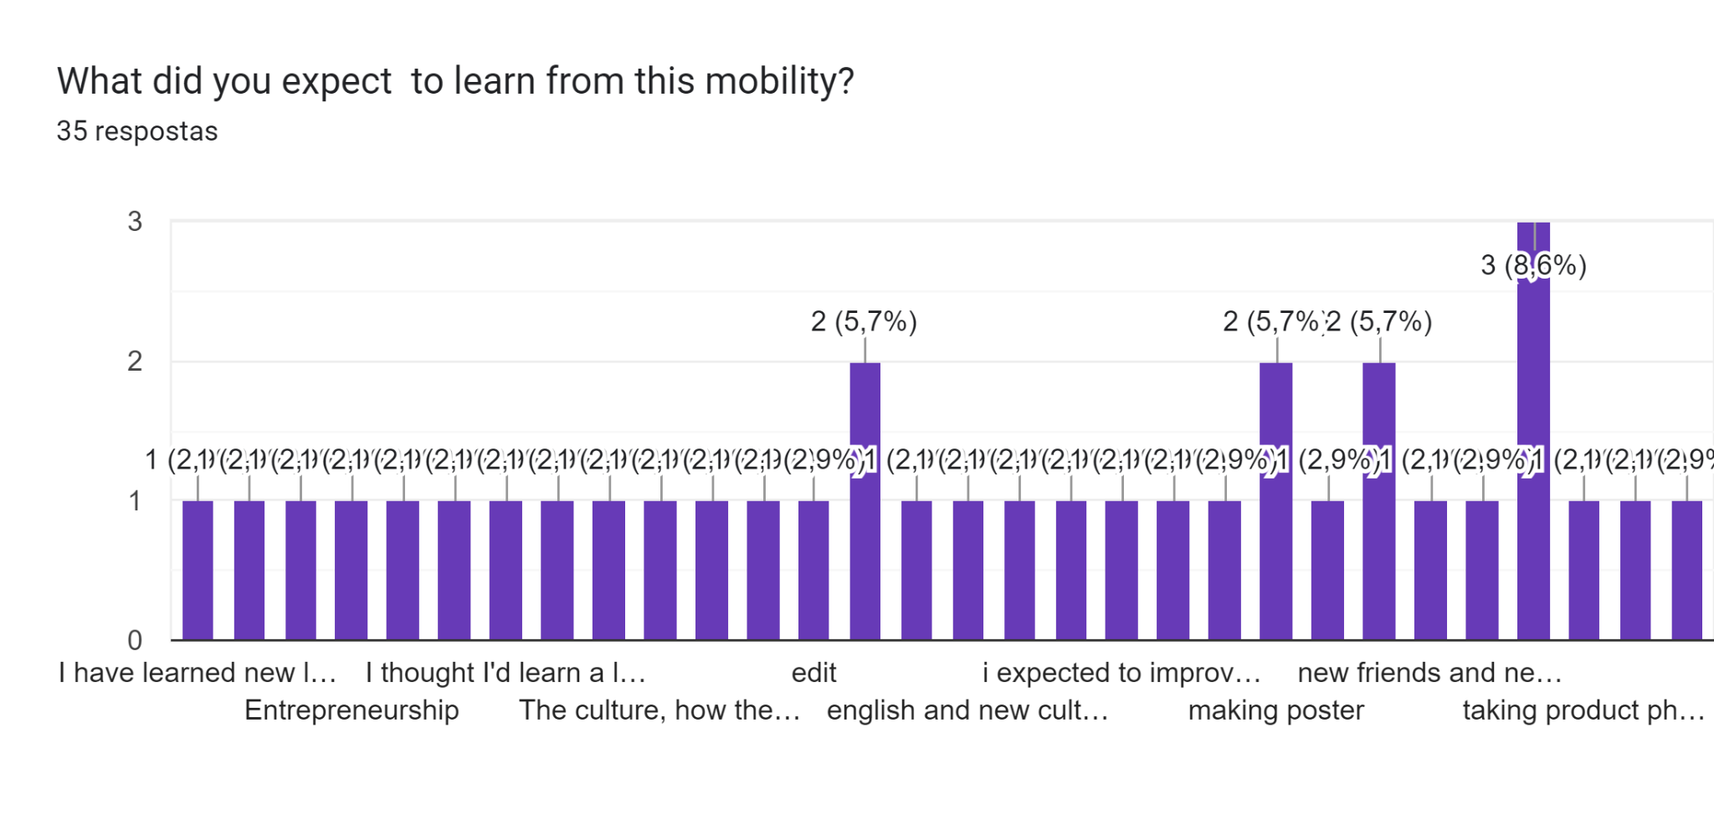

After analysing the programme the majority of the students were expecting to improve their language skills and learn more about the other partner’s cultures and countries. Communication skills were always the target, nevertheless the activities related to editing video and photos and even creating posters had also a high level of expectations.

**What difficulties did you have at the beginning of this mobility?**

Clearly the communication effectiveness was a problem for these students. Most of them had real difficulties interacting whether with the students or with the teachers. The language barrier was obviously an obstacle that in some situations didn’t allow the students to get the gist of the activities or to interact and cooperate as much as they could and as they were supposed to. Some students referred to the activity of taking photos from the products as being a difficult one as well as exploring the Da Vinci programme. Some found it hard to use the tools of this programme effectively and got a bit lost.

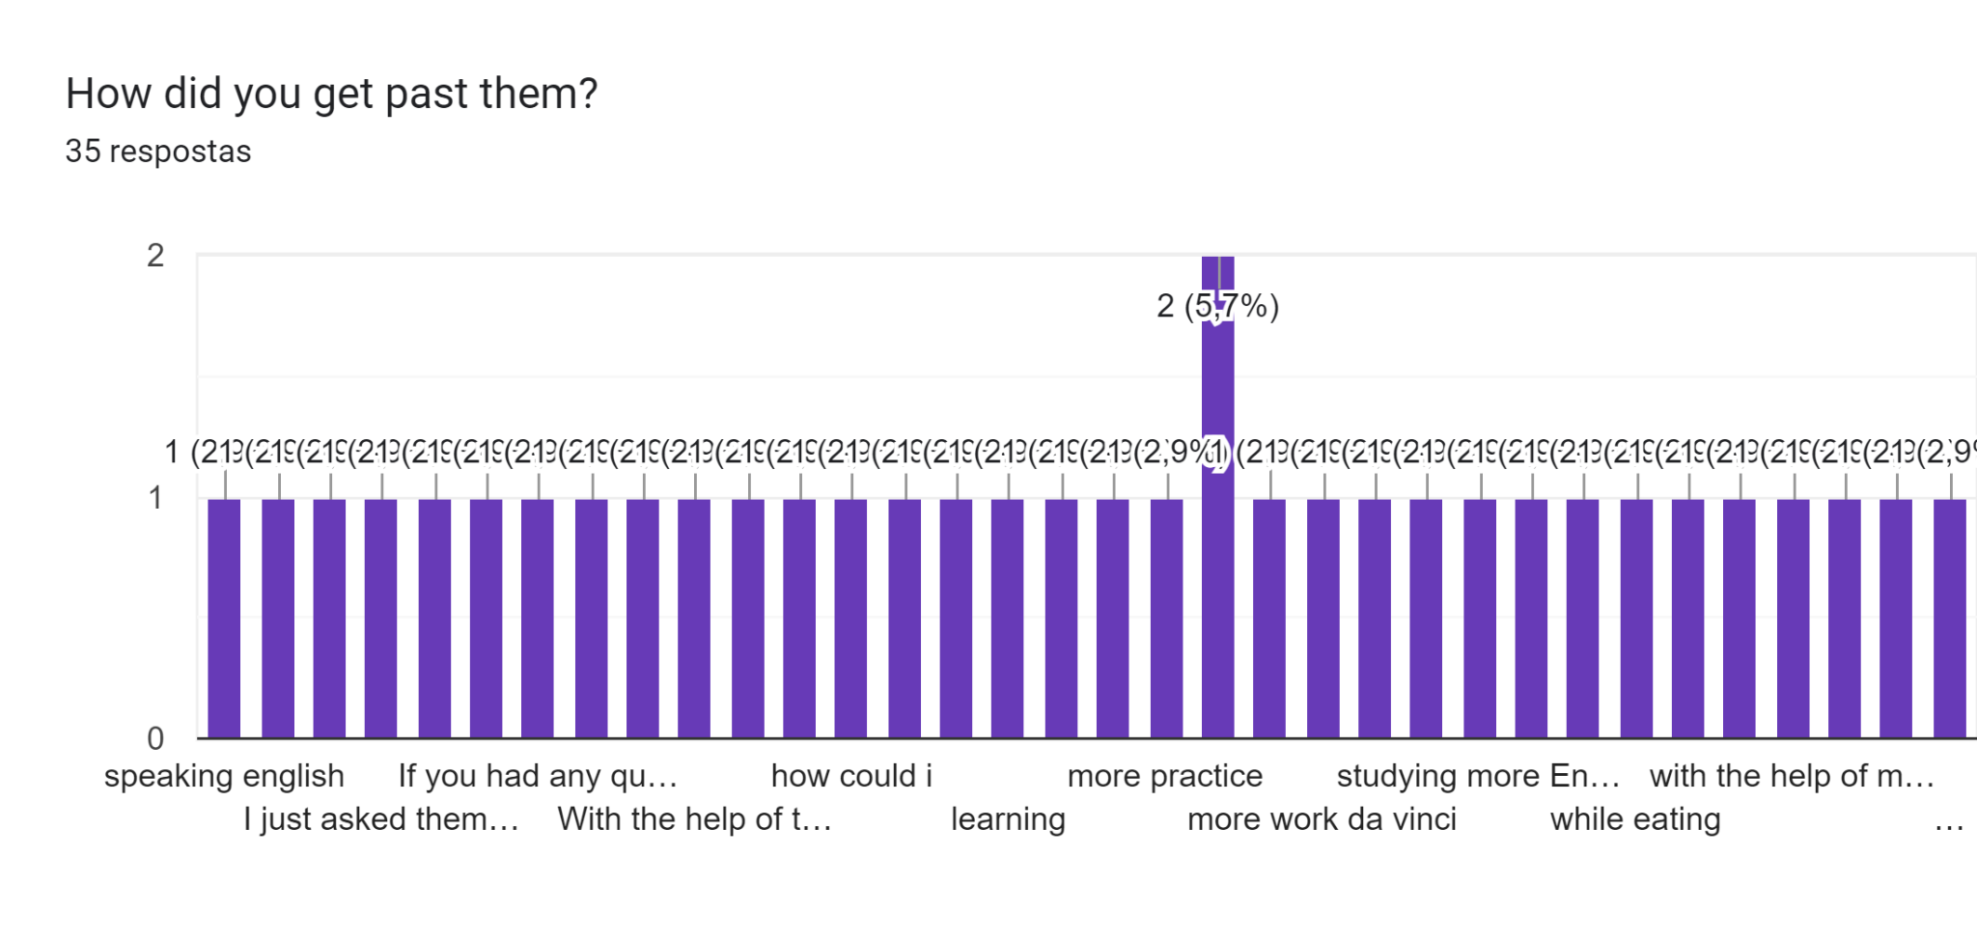

In a general way, most students tried to overcome their communication issues by trying hard. According to their answers, they didn’t give up and with the help of their teachers and other students they managed to speak and understand each other, even if for that they used simpler vocabulary and structures. On the other hand, some students said they used other forms of communication and included online translators as a helpful tool. All in all they felt they were able to adapt to this new situation, having teamwork as a basis for their improvement.

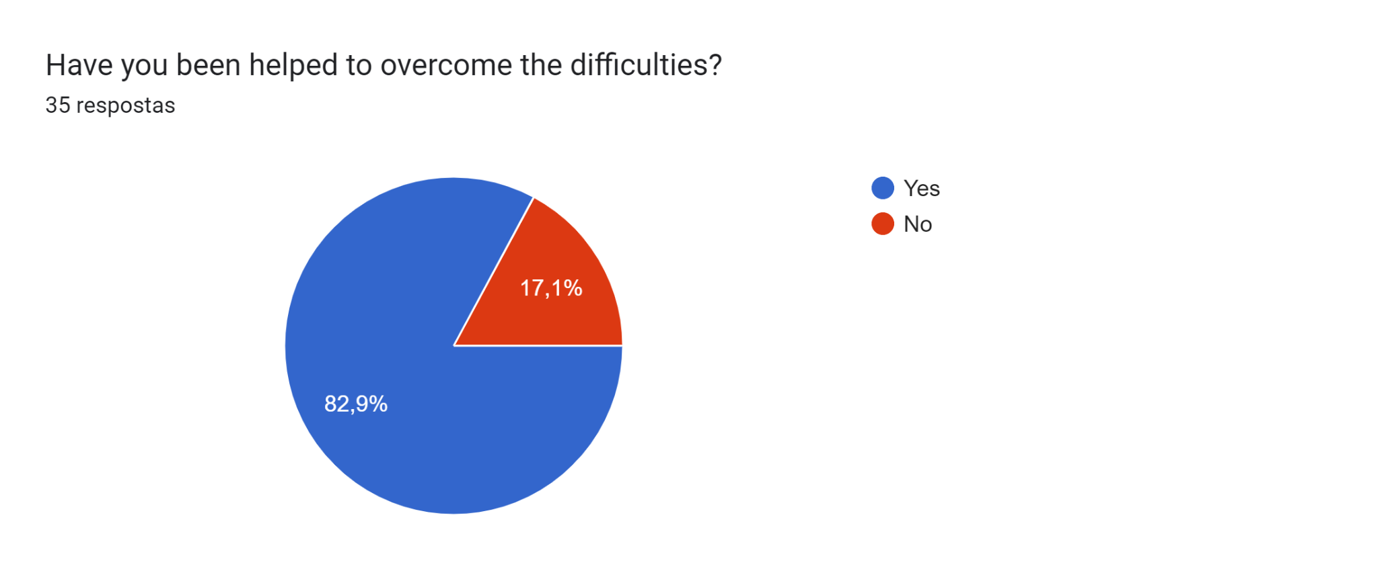 Only six students considered not to have been helped to overcome the difficulties. The remaining students have been helped to overcome the difficulties during the activities.

**If the previous answer was affirmative, say how you were helped.**

As it was previously mentioned teamwork was very important to achieve everyone’s goals. In fact, generally, students felt they were always helped when they needed, whether it was by the teachers or by the different students. The communication problems were solved mainly through gestures or online translators and some students really made an effort to interact and cooperate with each other, despite all their difficulties. As for the more specific tasks, such as designing the posters or editing videos and photos some of the students said that they felt supported by the Turkish students and teachers experts on those areas.

**During the mobility**

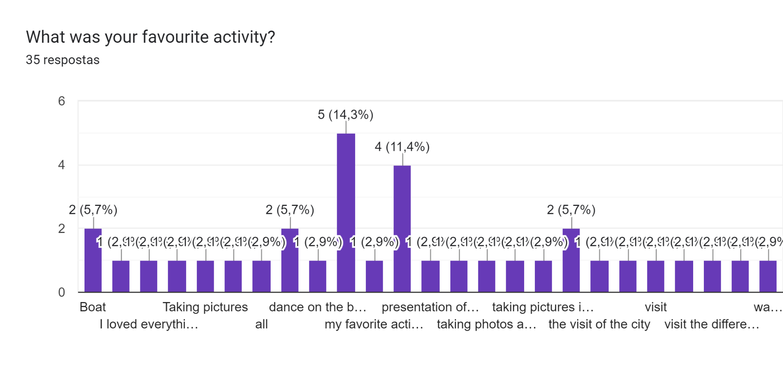

The students’ favourite activities were clearly the visit to Istanbul and the boat trip. On the other hand, 6 students considered taking pictures as their most interesting activity, followed by the video and photo edition. Poster design was mentioned by 4 students and curiously 2 students said they enjoyed everything about this mobility. 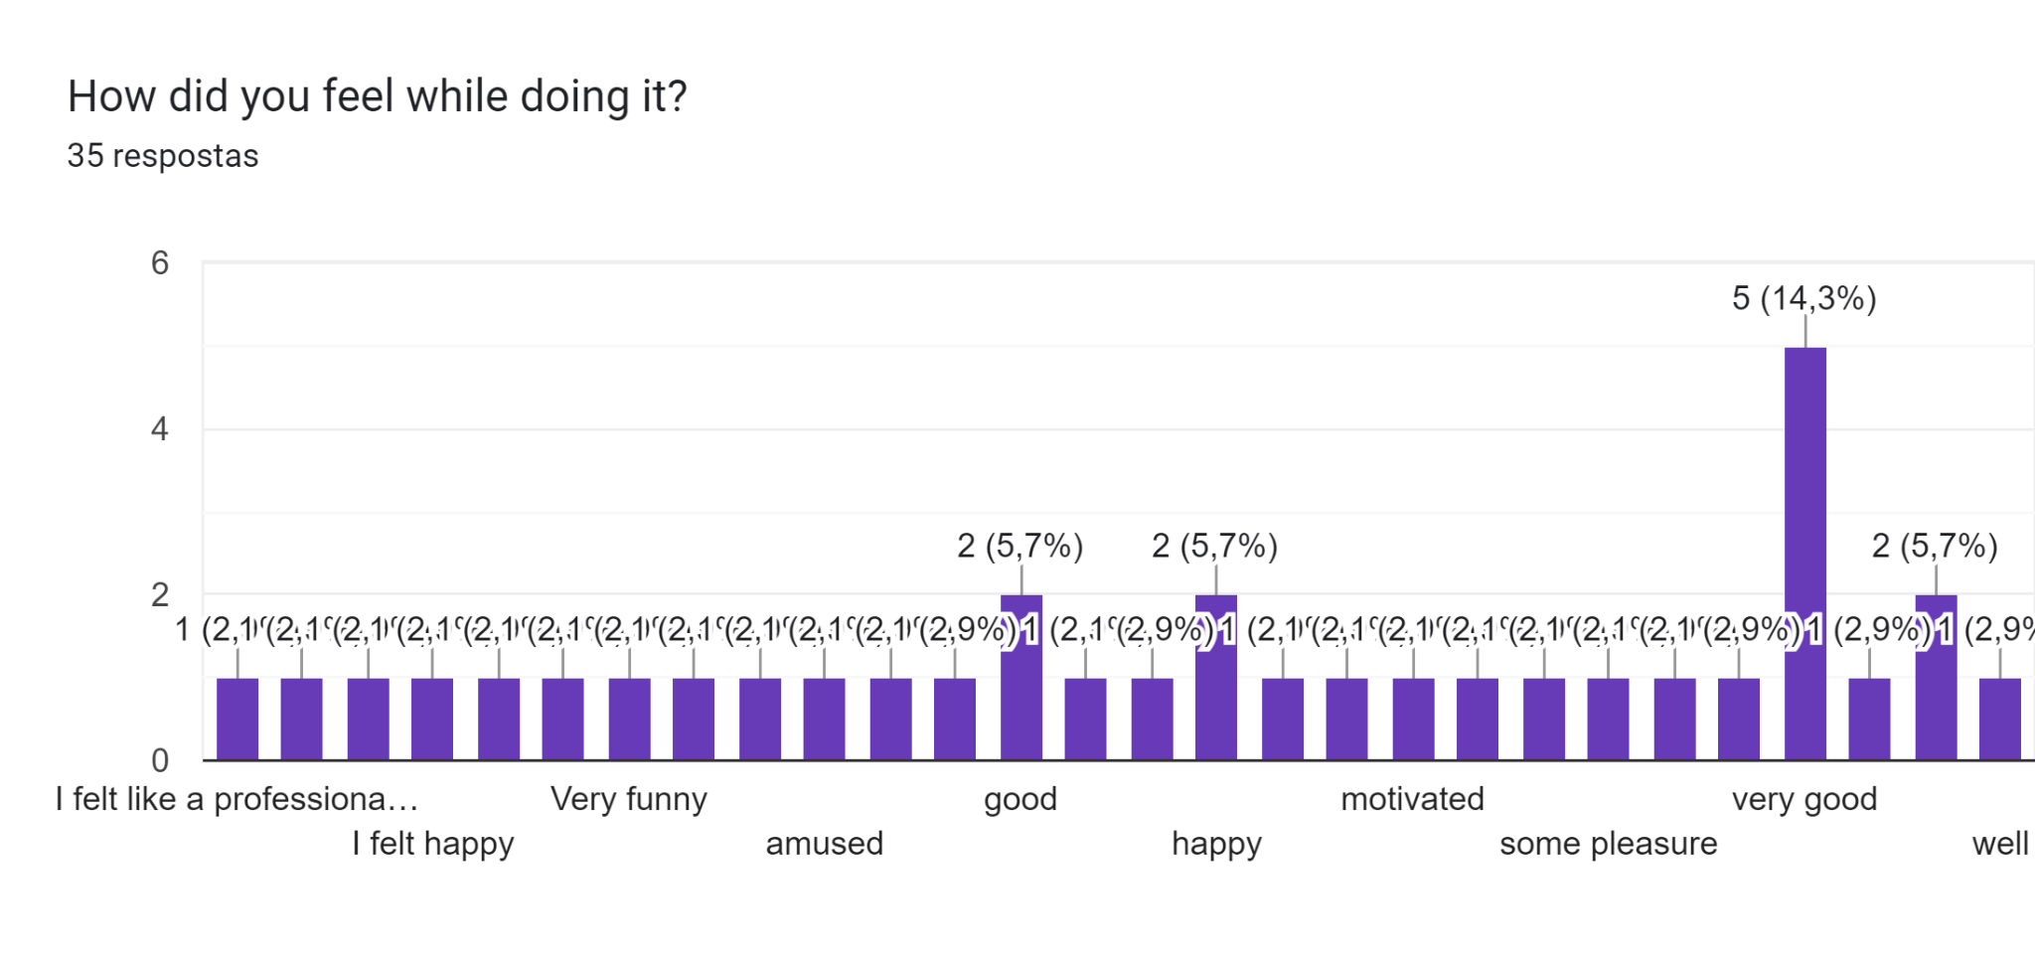

We may say that all the students felt very well throughout this mobility. Feelings such as happiness, amusement and cheerfulness were commonly mentioned. One student said that he felt like a professional highlighting the practical side of the project.

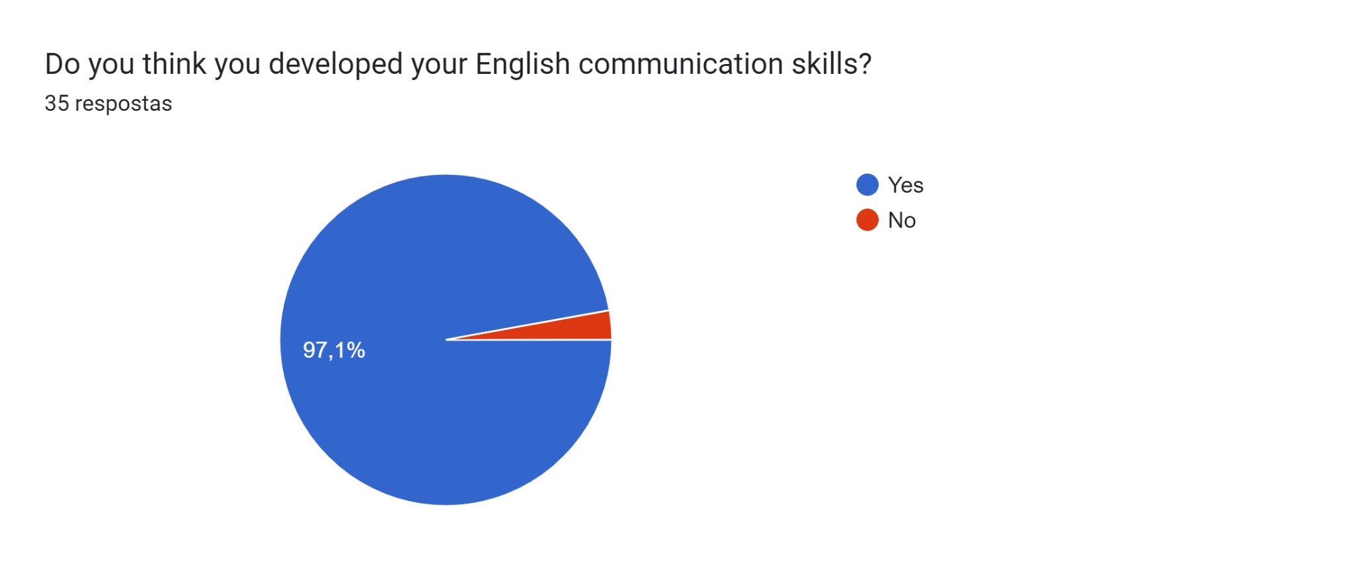

The students believed that they developed their English communication skills.

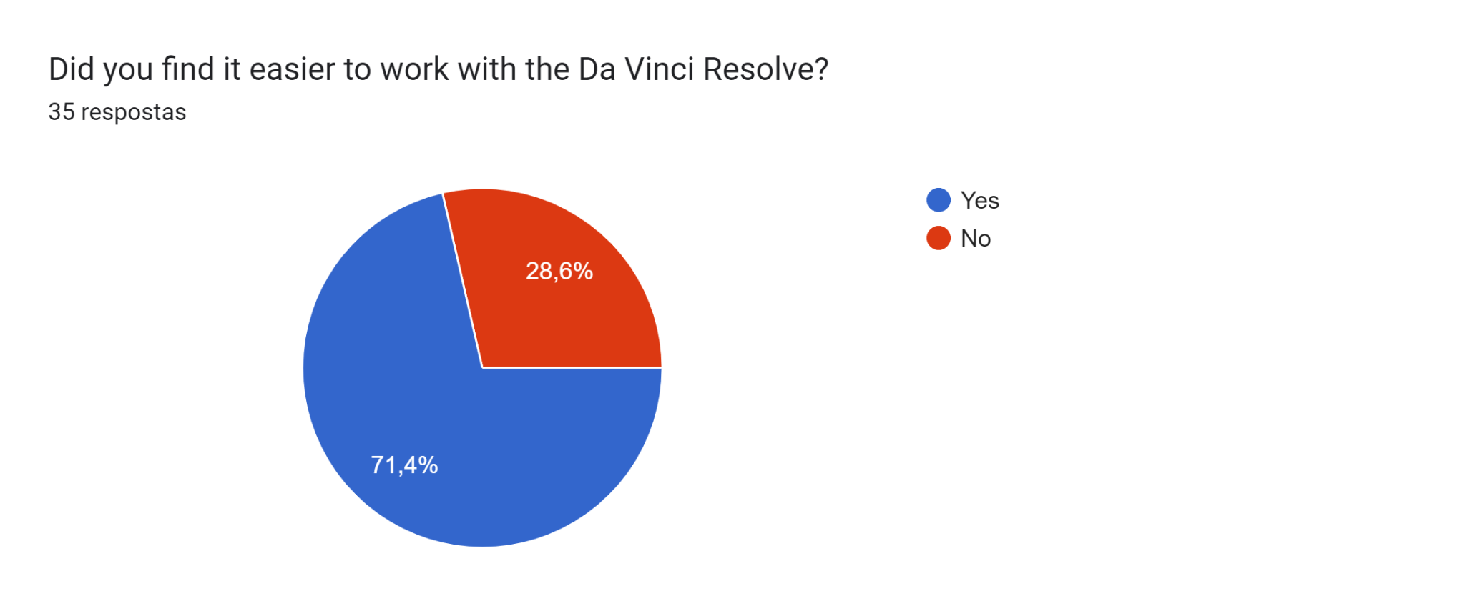

Most of the students thought working with the Program Da Vinci Resolve to edit video was easier. Ten students considered that editing video with DaVinci Resolve was difficult.

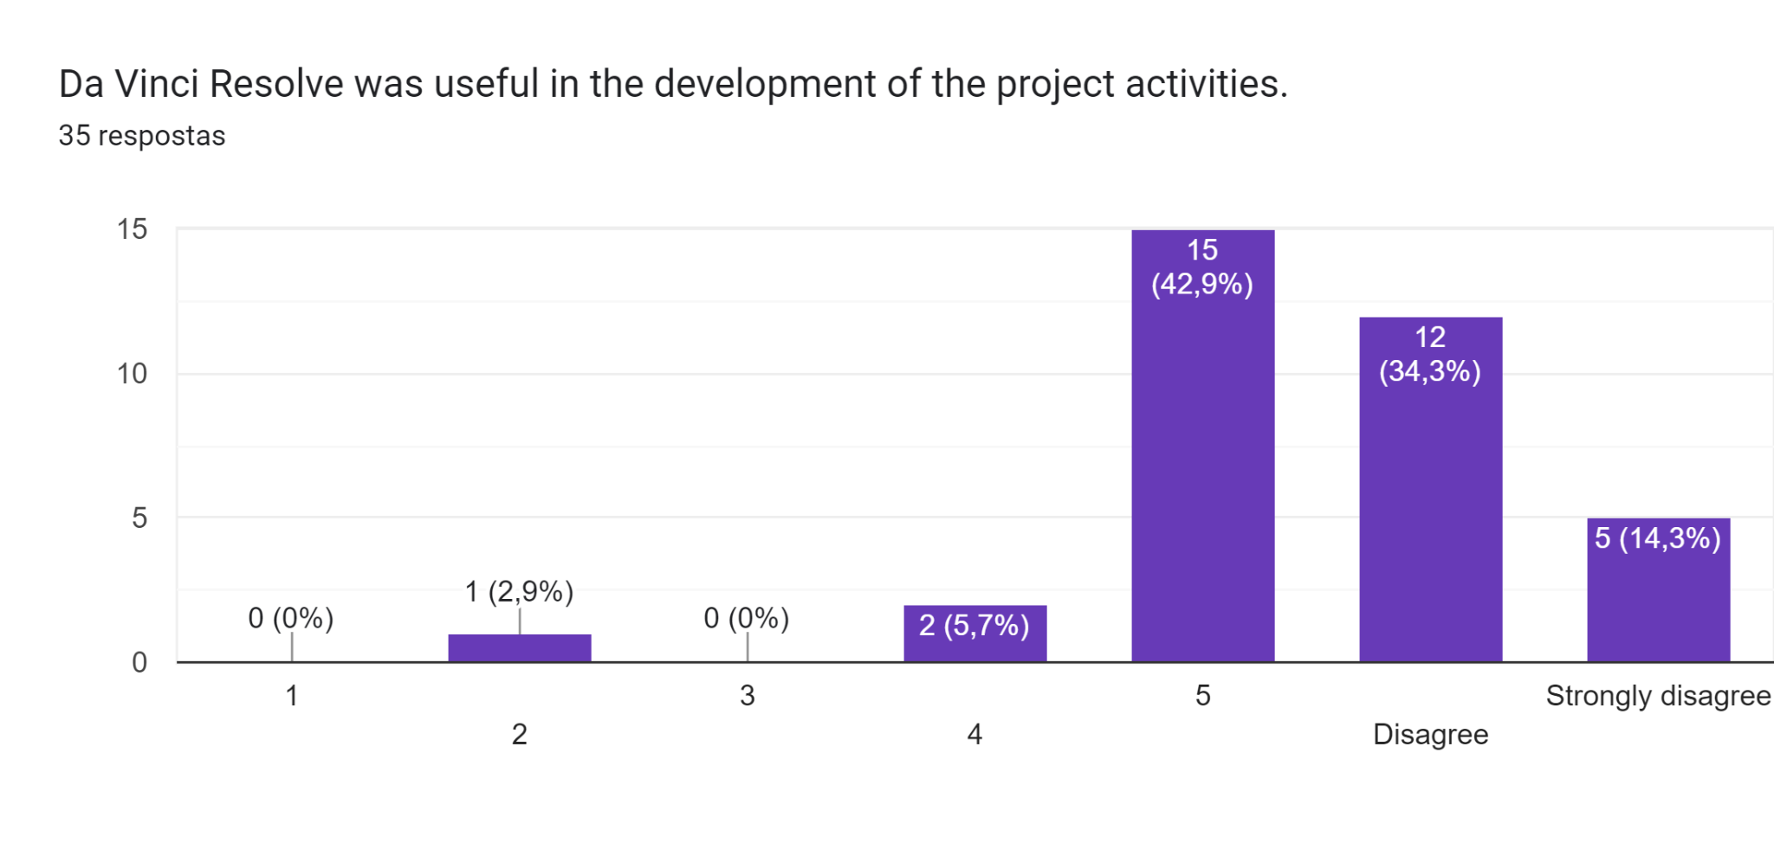

All the students agreed that DaVinci Resolve was useful for the exception of one student.

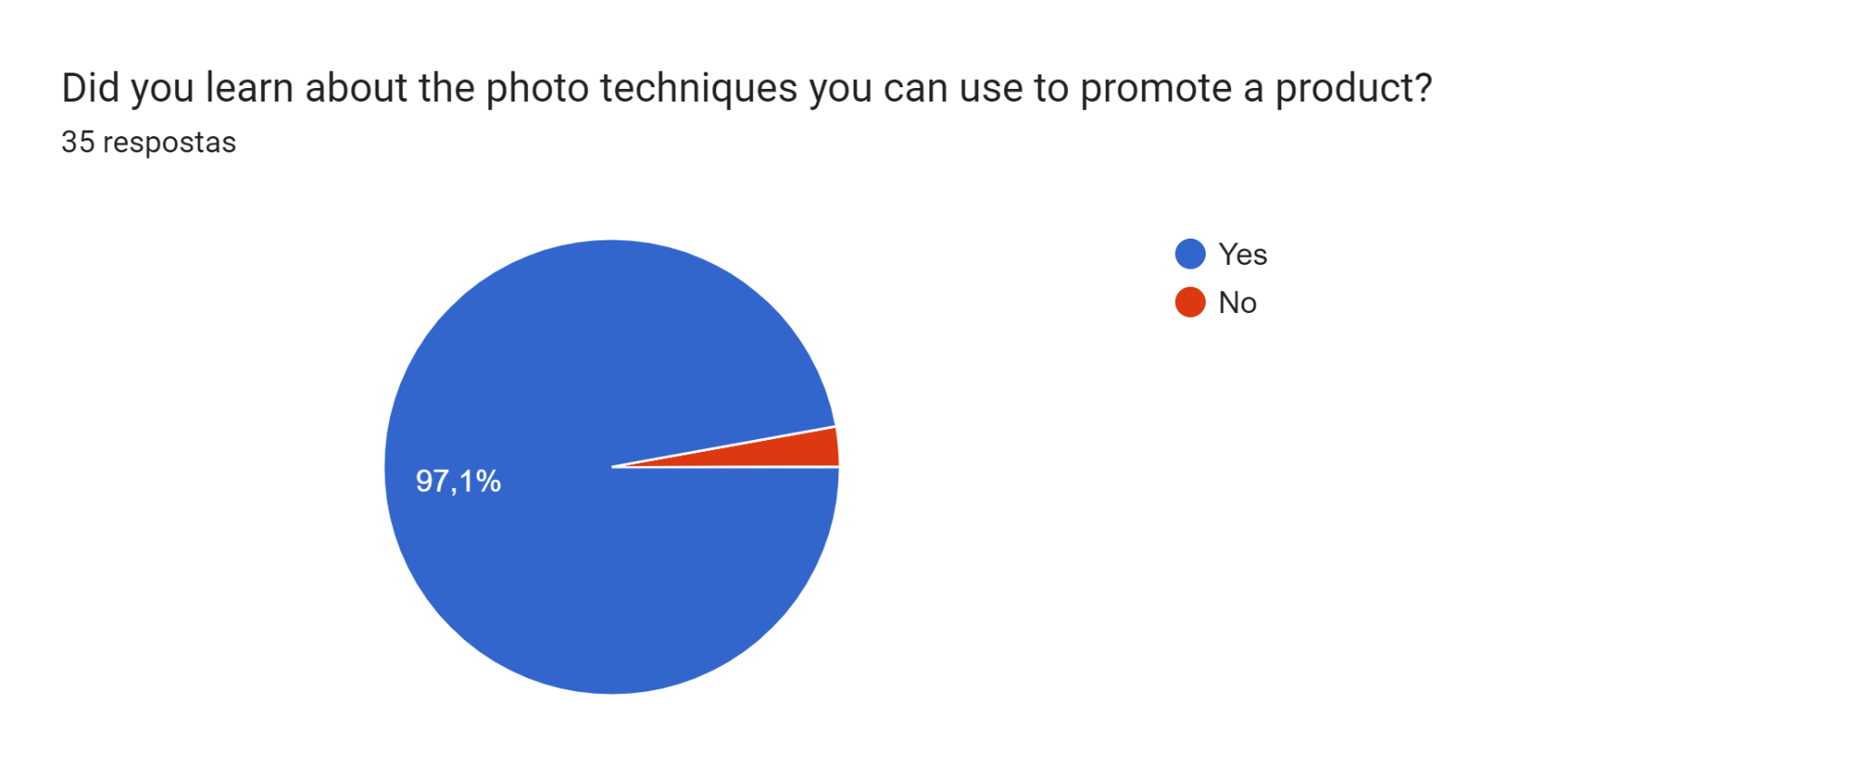

To promote a product the students had the opportunity to learn about the photo techniques with a photojournalist expert who taught them some tips they should apply to promote each product.

With the exception of one student, everyone considered that they were able to learn about the photo techniques so they could later promote the product.

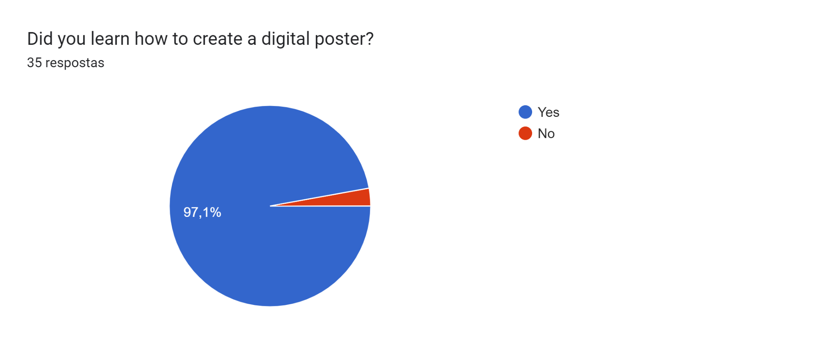

During the mobility the students developed skills to create a digital poster to promote a product. For the exception of one student, everyone considered that they had learned how to create a digital poster.

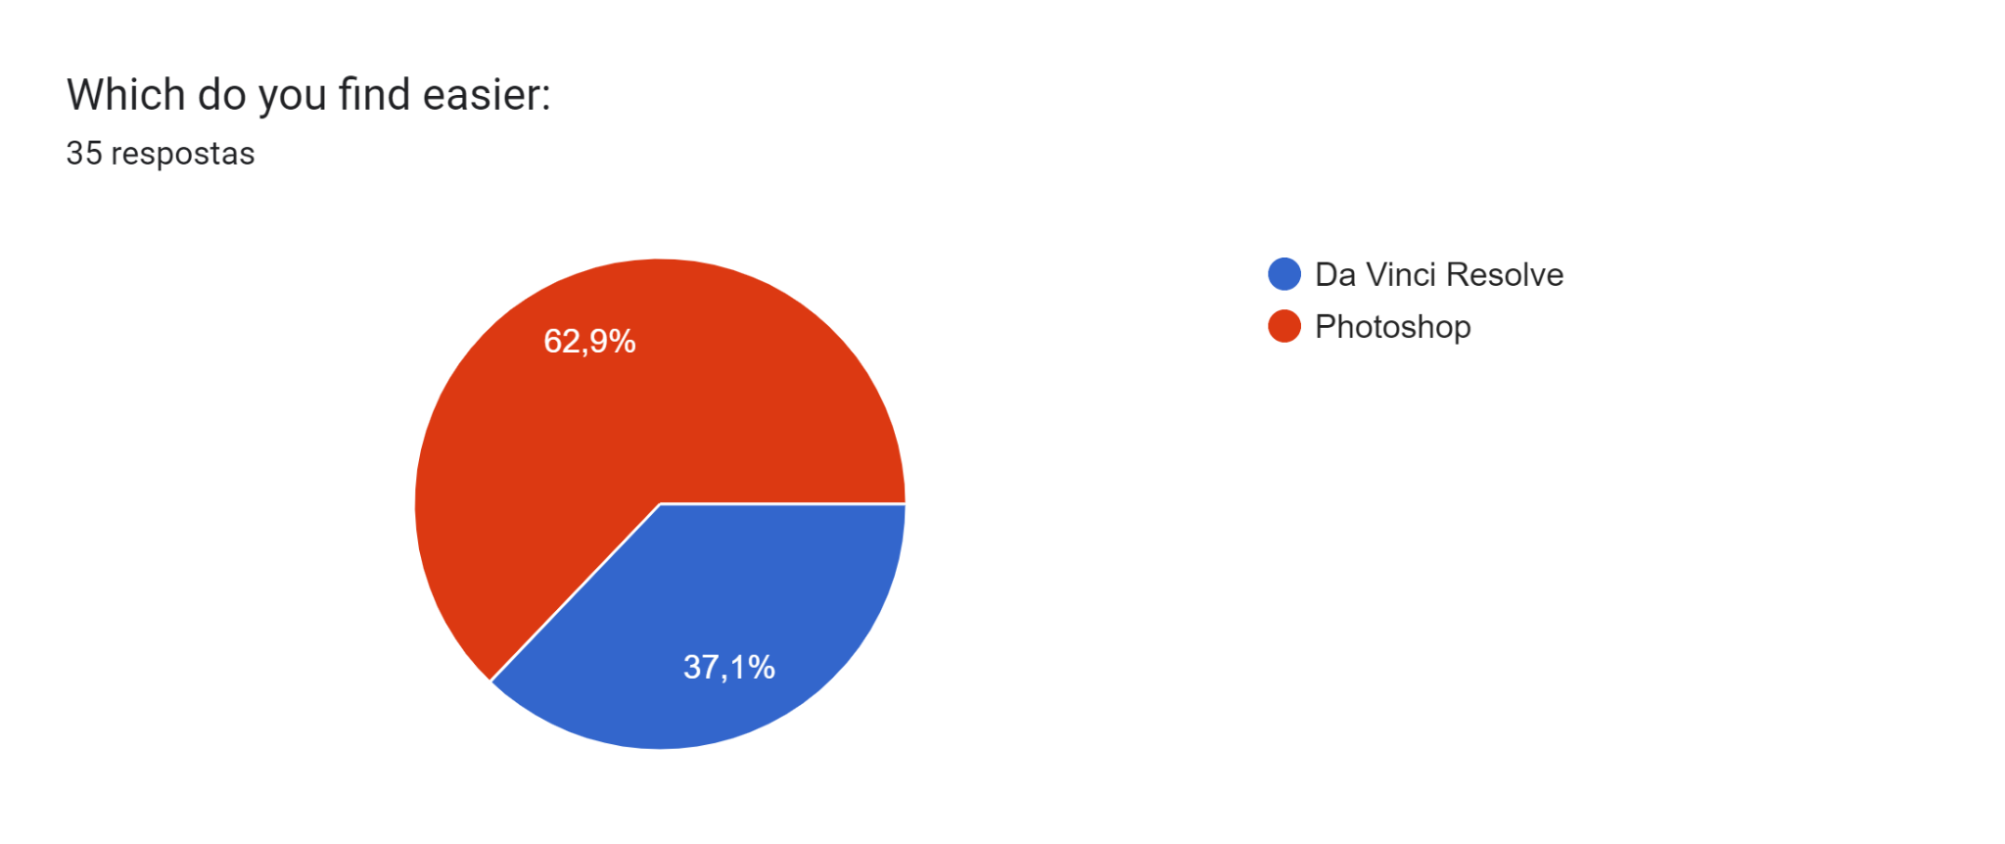

More than half of the students thought that Photoshop was easier than DaVinci Resolve.

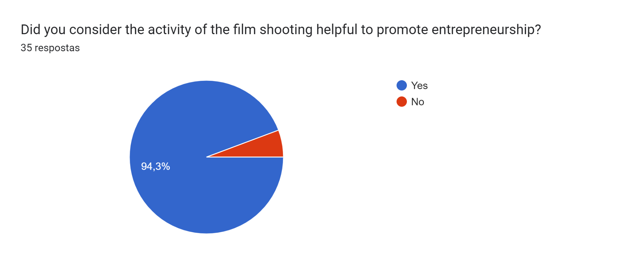

With the aim of promoting entrepreneurship the Turkish team dynamised several activities, such as film shooting with Turkish teachers who were experts. Most students believed that it was helpful to promote entrepreneurship and it accomplished its goal.

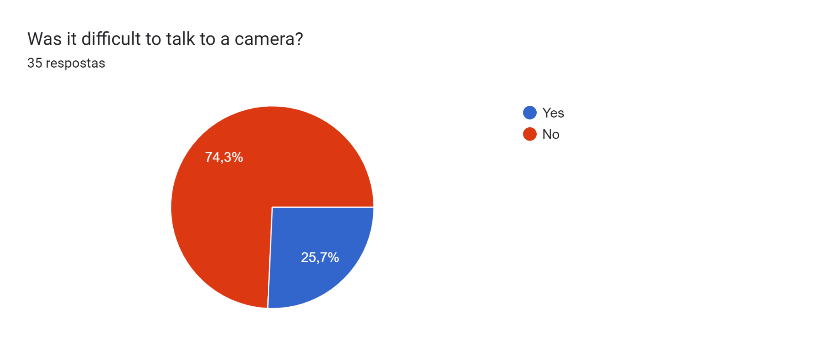

During a film shooting, the students developed communication skills by having the opportunity to be a reporter for some hours. They had to talk to a camera about entrepreneurship. Only a quarter of the students considered it difficult talking in front of the camera.

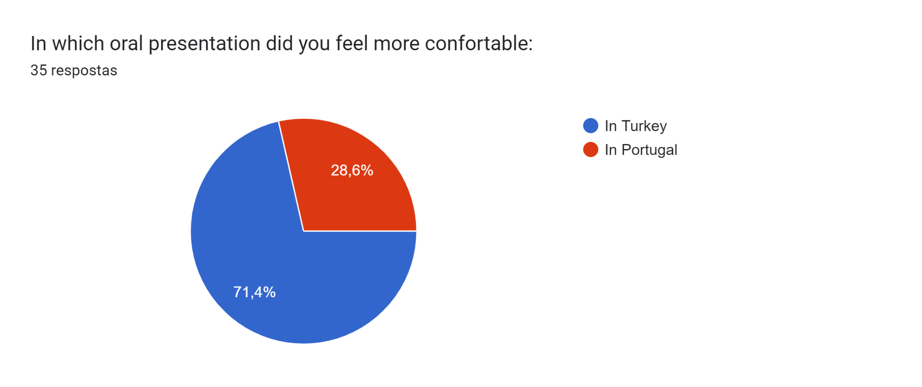

During the mobilities the students had the opportunity to develop oral and written communication skills in English. Most students considered that oral presentation in Turkey was easier than in Portugal.

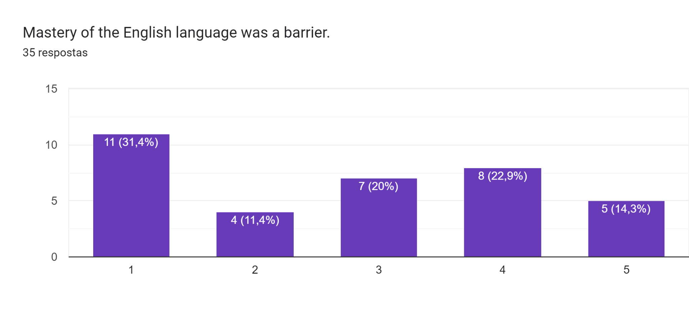

For effective communication along the project it is important to master English, because it is the only language which allows students to interact, collaborate and communicate with each other. 15 students considered their skills in English weren’t a real obstacle for communication. Only 9 thought the opposite: that their level of English was a real weakness. All in all, we may conclude that mastering English is compulsory to achieve the highest level in our project.

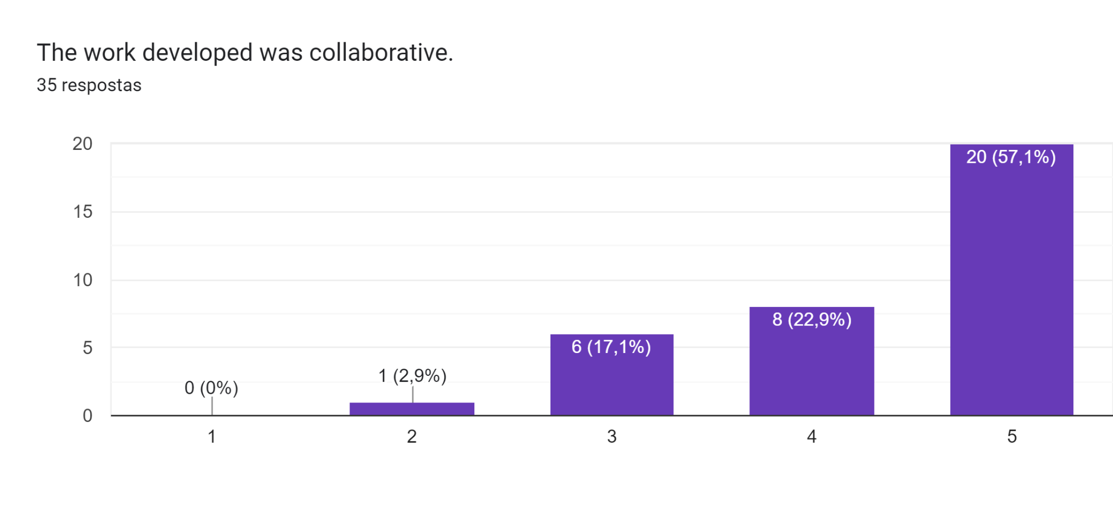

During the Turkish mobility collaborative work activities were used. The majority of the students considered that there was collaboration and cooperation during the work.

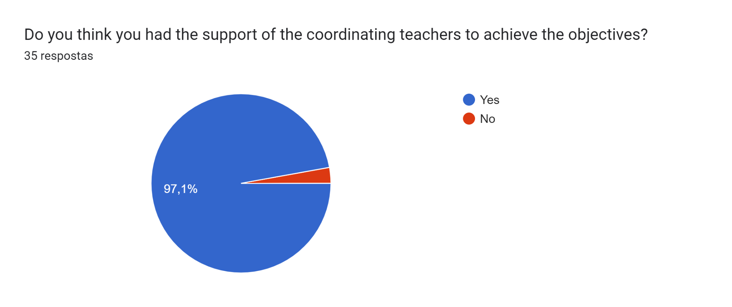

During the mobilities the support of the coordinating teachers was fundamental to achieve the project objectives. Everyone, except one of the students, believed that that support was effective and has enabled the achievement of these goals.

**Pos mobility**

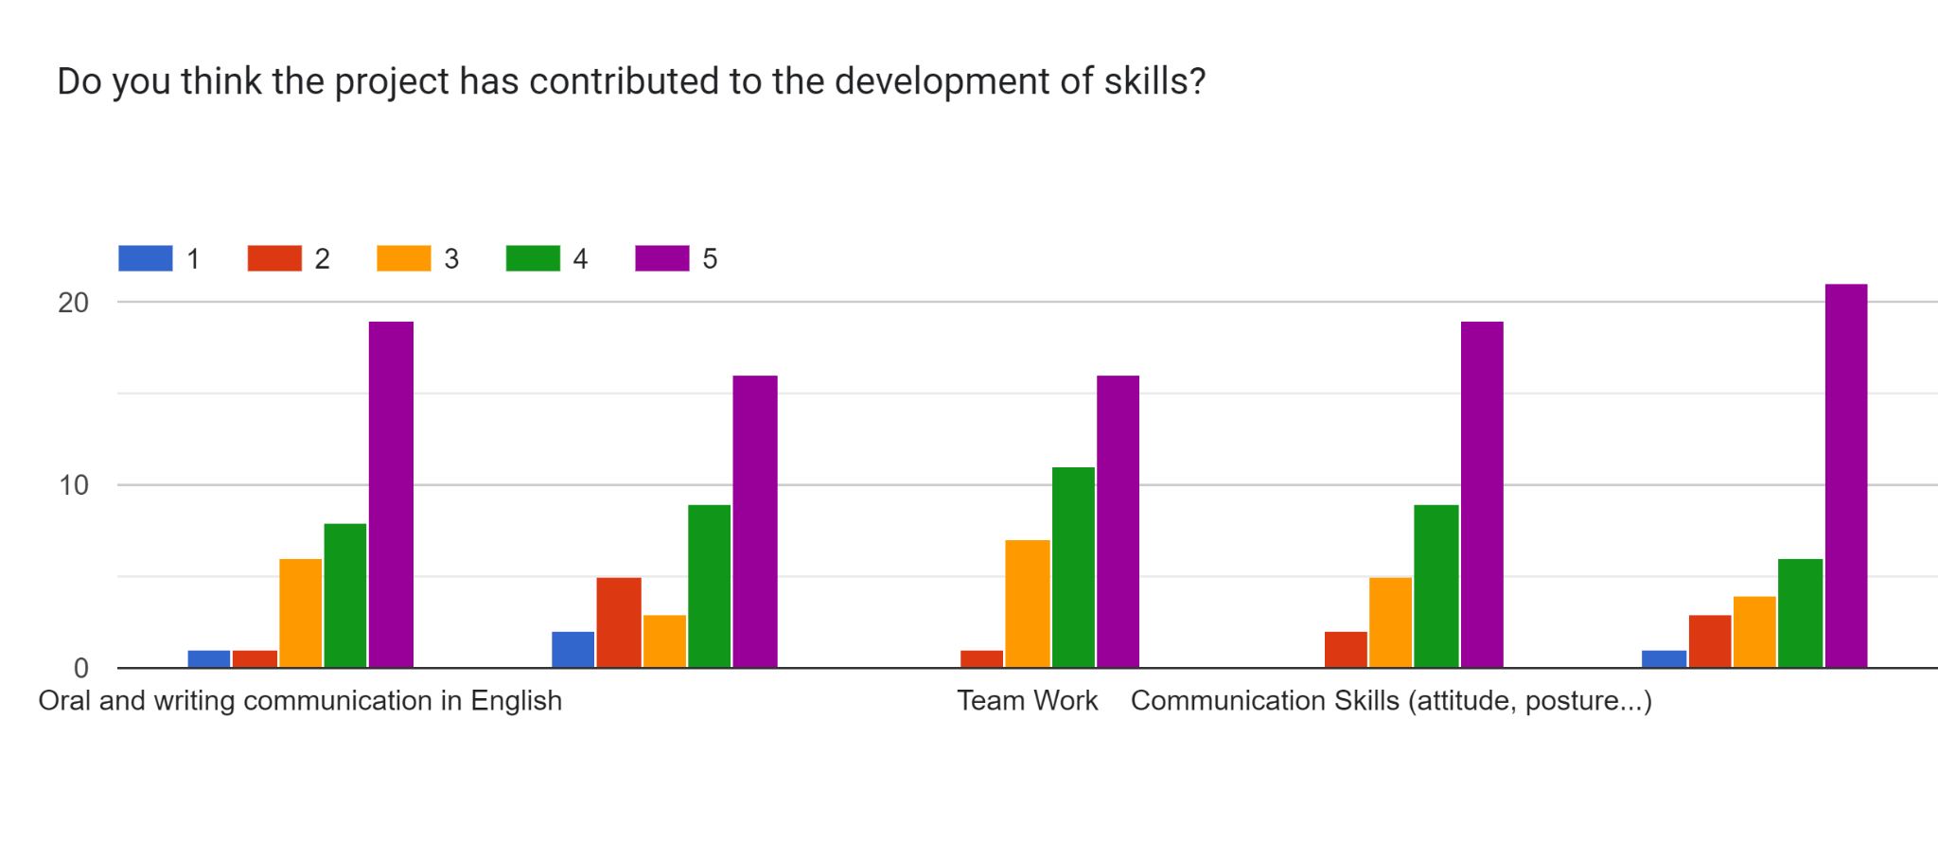

For this mobility, a set of activities promoting the development of various competences were planned such as oral and written communication in English; Computer Skills; Team Work; Communication Skills (attitude, posture…); and photo editing. We questioned the students in the sense of understanding which ones they think they have developed the most. As a result, we found that the students developed more photo techniques, followed by the communication skills. Teamwork and computer skills were the least developed according to the students, nevertheless still important abilities for their future life.

**Give one suggestion of something you would do differently**

According to the majority of the students, there wouldn’t be much to change on this mobility. Some students mentioned the organisation of the group, with the aim of improving the interaction of the students from the different countries.