

From the 10 teachers who went to the Portuguese mobility and answered the form 2 are French, 1 Spanish, 3 Turkish and 4 Portuguese.

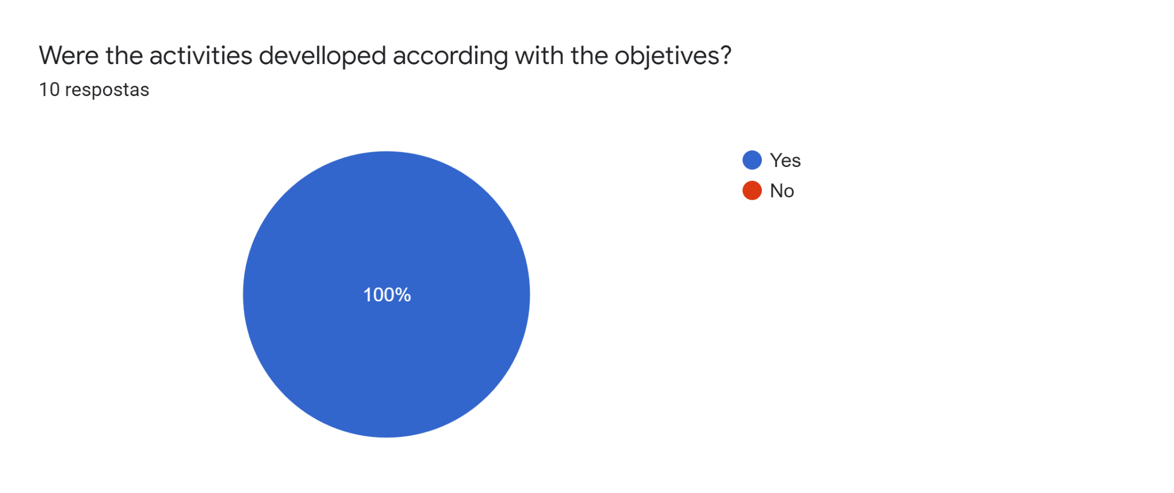

All the teachers considered that the activities were developed according to the objectives.

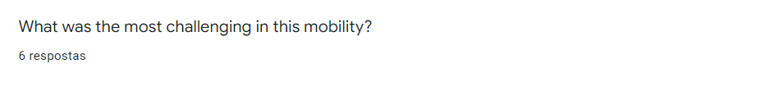

Two teachers considered the number of students to travel and to do the activities during 5 days was the most challenging in this mobility. One of the teachers thinks that the cultural day had many activities and that despite being tiring, it was fun. Two teachers considered the communication with students and making some students talk in English the most challenging. The other teachers considered the most challenging task was to monitor the work all together. Finally one teacher said he had more difficulty managing time after activities.

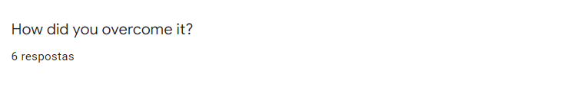

Most teachers overcame the challenges in this mobility very well. One of the teachers overcame the challenges trying to be punctual and the other tried to get all teachers involved in activities. The other one tried to use different strategies for communicating, like speaking slowly and helping the students to make complete sentences. The last one considered overcoming difficulties with the help of hosters.

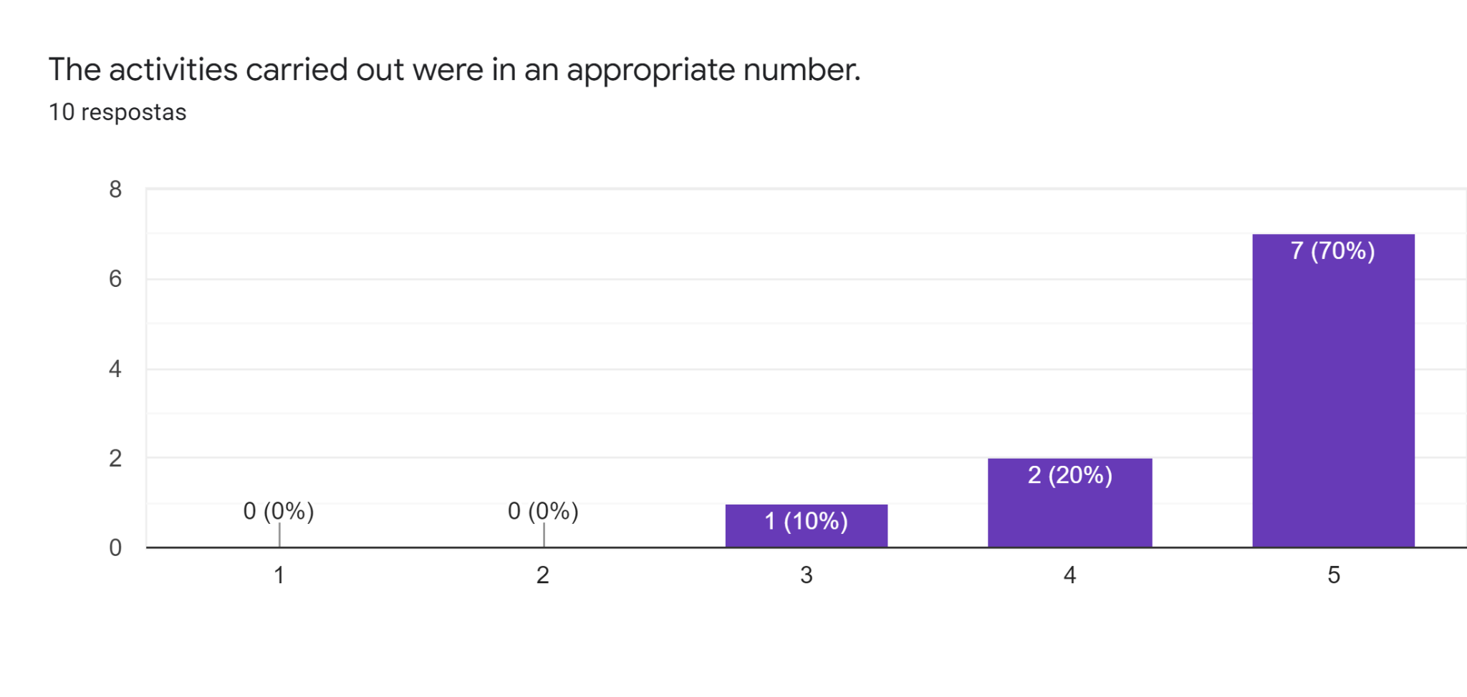

All the teachers agreed that the activities developed were in an adequate number, seven of which strongly agree.

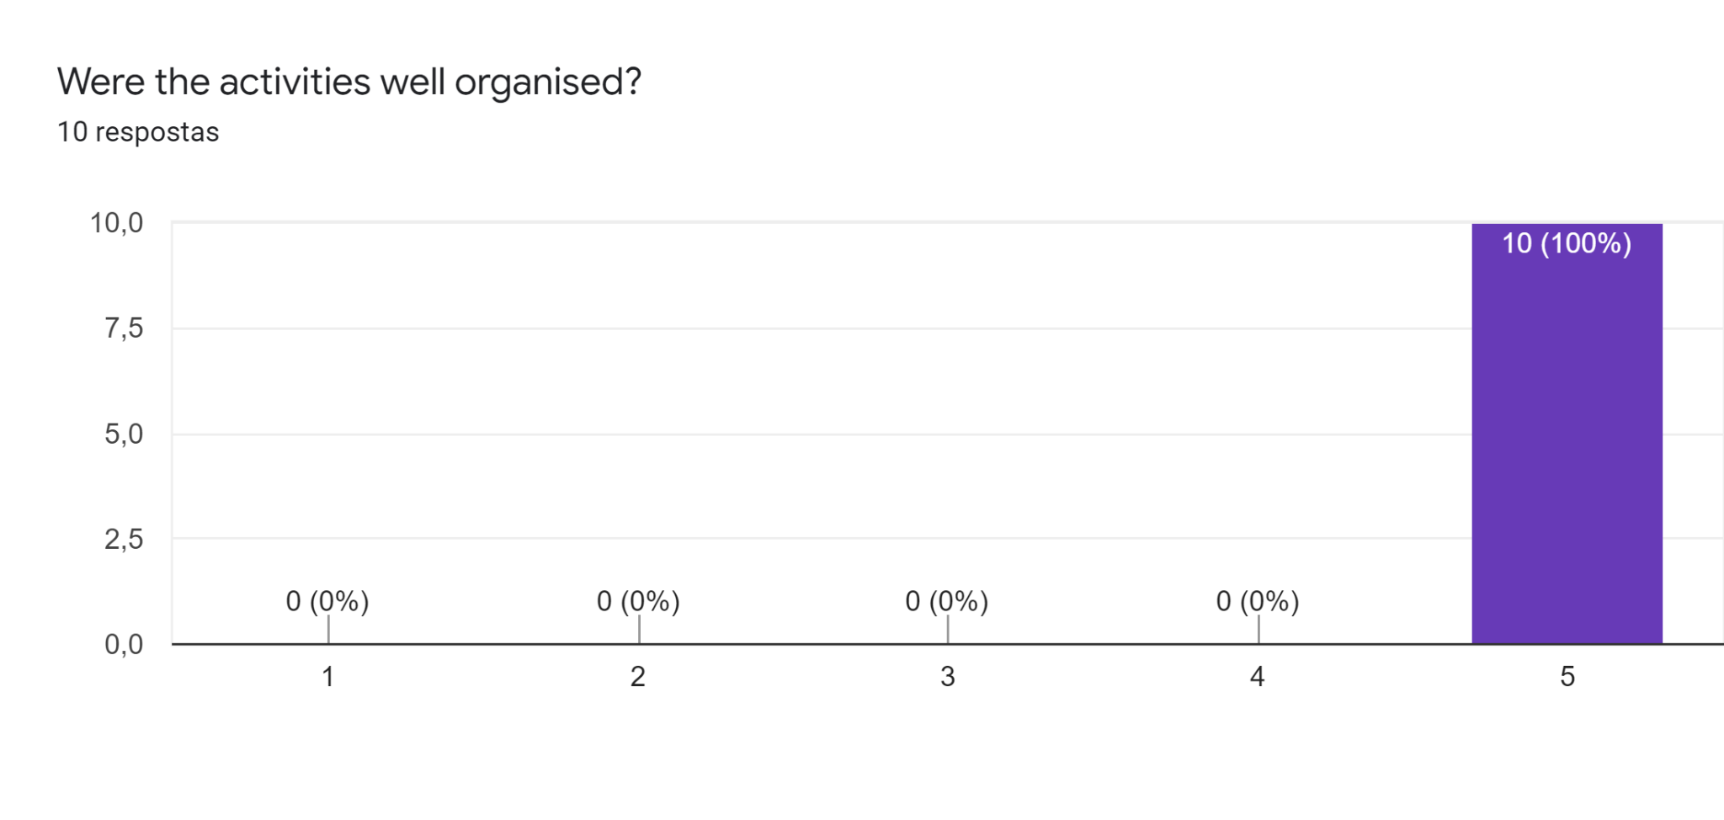

All of the teachers fully agreed that the activities were well organized.

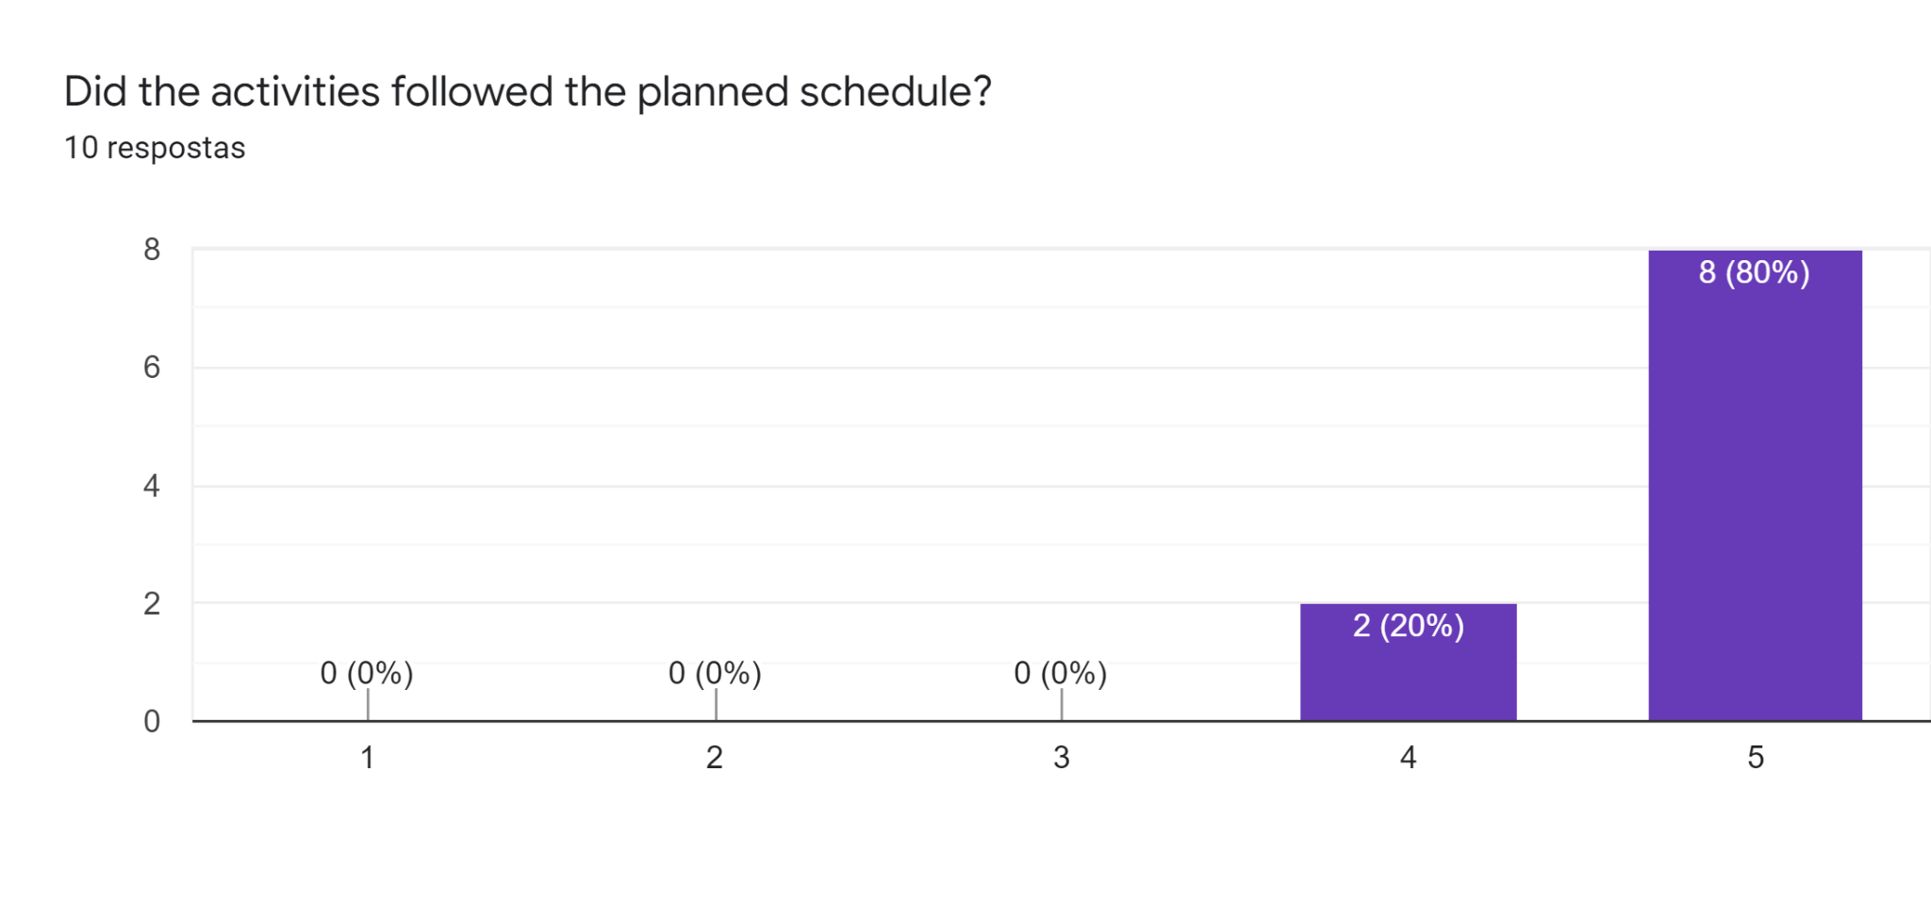

All the teachers considered that the activities followed the previously announced plan.

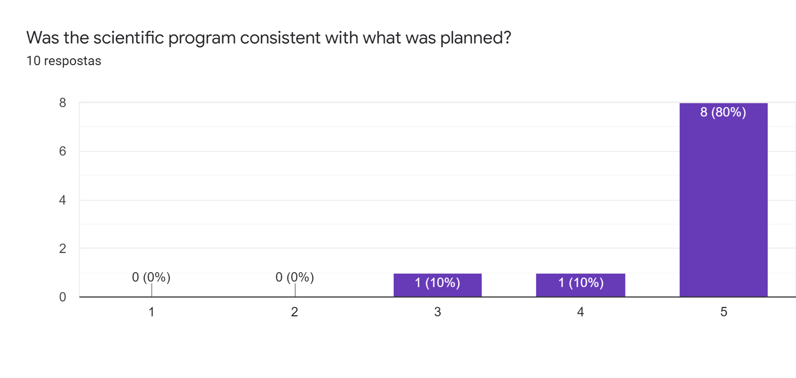

The teachers agreed that all the activities related to the scientific program fulfilled what was previously planned. A French and Spanish teacher did not strongly agree with the above explained.

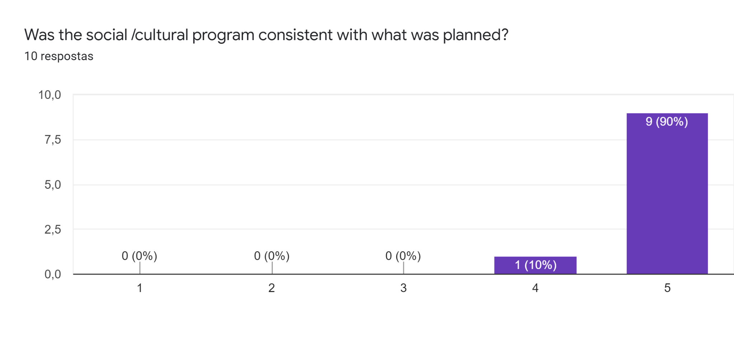

All the teachers considered the social/cultural program developed was in line with the plan previously presented.

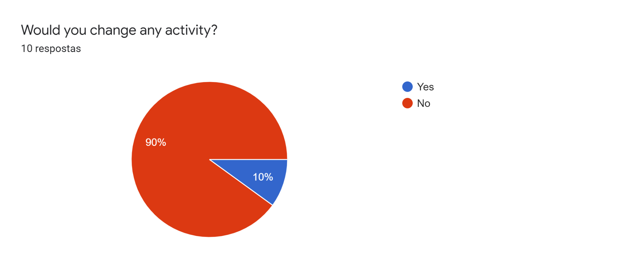

One of the French teachers thought that the video workshop should be changed.



There are different opinions about what went best during Portuguese mobility. Some teachers pointed out that the students were really happy with the mobility and the efforts that were made by students to communicate in a foreign language. The other one empathizes the good organization. Some teachers considered teamwork and cooperation one of the strengths. Two teachers said the visit to cork enterprise and video editing were the most important activities. Finally the teachers referred both the heterogeneity and the diversity of places where the activities were carried out as an important strength from the project.



As for what could have gone better, we may mention the difficulty of the students to work in international teams, maybe because of the language barrier. Unfortunately, this handicap does not always allow students to exchange ideas and interact as the teachers would like to. One teacher considered that the workshop about Da Vinci Resolve for the students to learn editing videos did not have an adequate explanation and two teachers referred the weather as a weakness.



Concerning the opportunities that the development of these activities allowed, the teachers had the opportunity to share experiences with the other teachers. Discovered the educational system and Portuguese culture. Furthermore one teacher considered that this mobility allowed to improve the next mobility. The other teacher considered that this mobility allowed to overcome people's difficulties in speaking and discovered new realities: different students, different teachers and the opportunity to practice other languages.



Most teachers reinforced that nothing prevented the development of activities.

One teacher considered that he did not carry out the activities at the moment and this hampered the development of activities. Finally one teacher considered there was a lack of communication in some periods.



All the teachers considered that the support given by the hosts was excellent, perfect, brilliant. They observed that they were well received and accompanied and the hosts providing tha answers to all the needs to everyone.