From the 47 students that went to the Portuguese mobility and answered the form 7 are French, 7 Spanish, 11 Turkish and 22 Portuguese.

**Pre mobility**

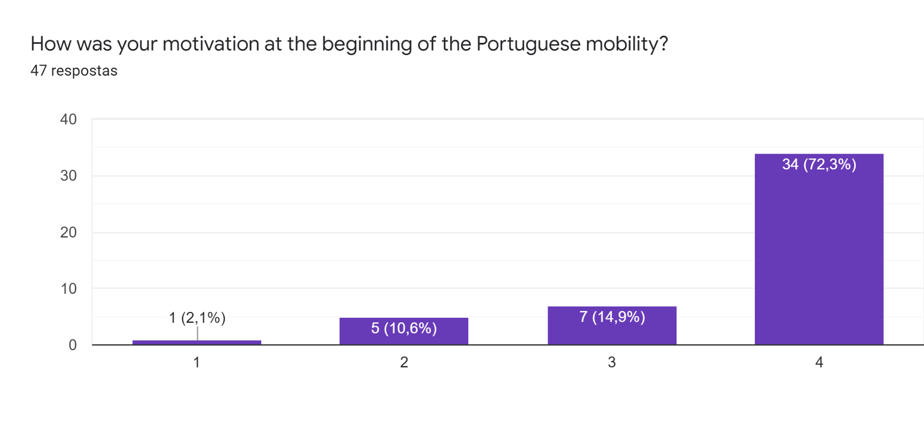

**What did you expect to learn from this mobility?**

Clearly the majority of the students expected to develop their communication skills, not only in the academic perspective but also in the personal perspective. The interaction with the other students and the need to communicate with each other was from far the most important aspect. Learning about other cultures, exploring a new country and discovering everything about a different city was also referred to as being some important areas in which their expectations were focused on. Furthermore, the development of different social skills such as the ability to work in a group was also mentioned by some of the students. After checking the plan of the mobility, some students also indicated that they expected to learn something about new apps, video and photo editing.

**What difficulties did you have at the beginning of this mobility?**

Analyzing the answers to this question we can easily conclude that the language barrier was the biggest difficulty that almost all students felt, whether it was because some of them had to struggle with their English limitations or in other cases they could speak English but they couldn’t make themselves understood.One student referred the video editing as a difficulty he found along the way and another felt it difficult to adapt, supposedly to the culture.

**How did you get past them?**

Curiously, the communication problem that students felt from the beginning was somehow solved by not giving up. They tried to communicate in English even if they weren’t totally comfortable with the language. They referred to the adoption of different strategies such as the use of simple structures of English, gestures, sometimes even the use of different languages and translation Apps. The teachers’ help was also mentioned as being useful to make them understand each other.

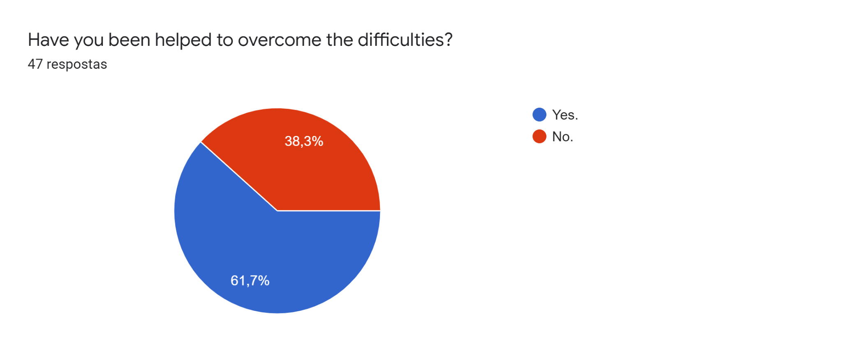

Most of the students have been helped to overcome the difficulties.

**If the previous answer was affirmative, say how you were helped.**

The students mentioned the help of the other students and of the teachers. In some cases they used digital translators, in other situations they had their colleagues or their teachers explaining in other words the instructions for the different activities and sometimes their own language was used to help them interact.

**During the mobility**

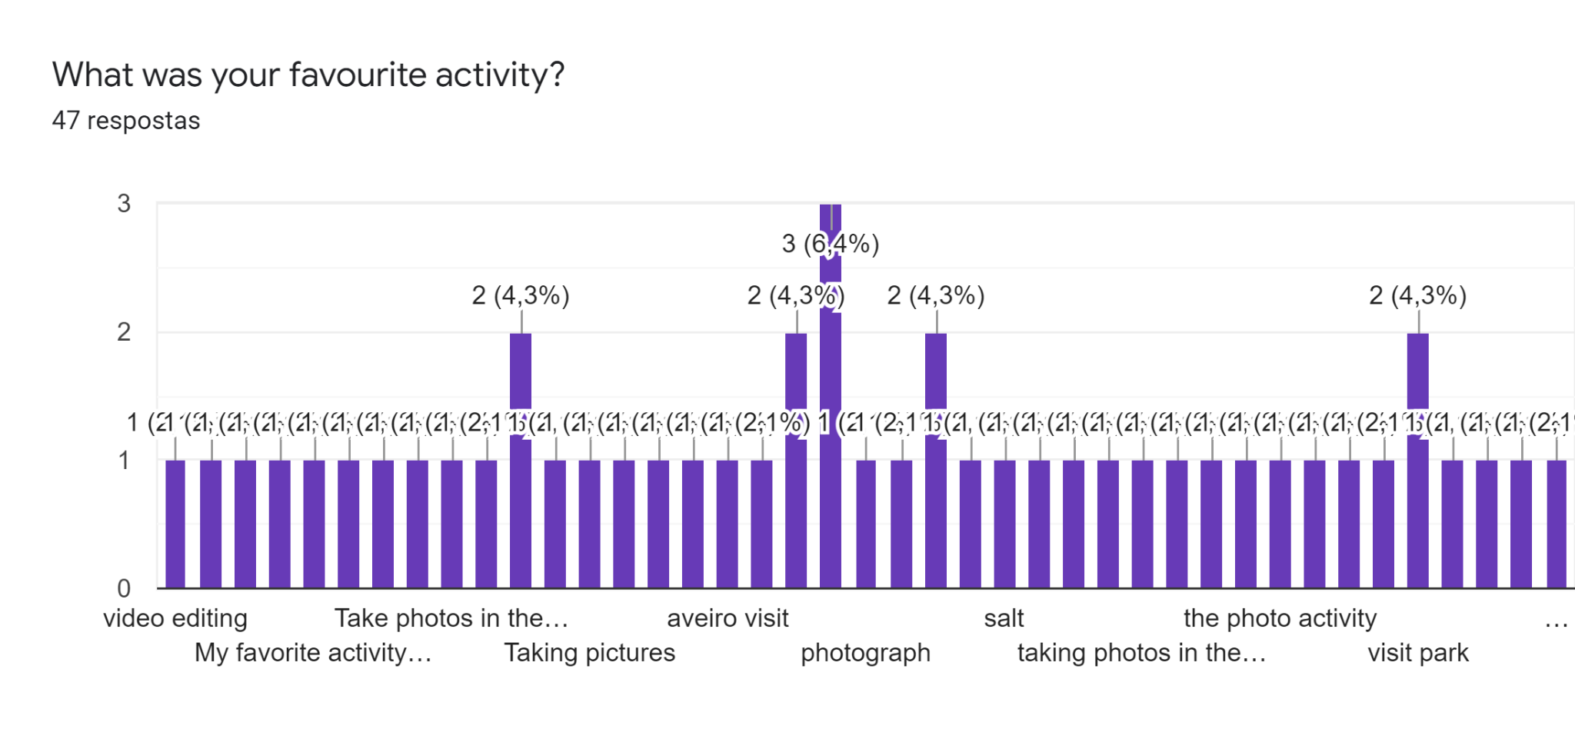

The photography workshop was the favourite activity for 22 students. 13 students preferred the cultural visit and the other 8 liked the workshops about video editing. Finally the last 4 had the firm visit as a favourite activity.

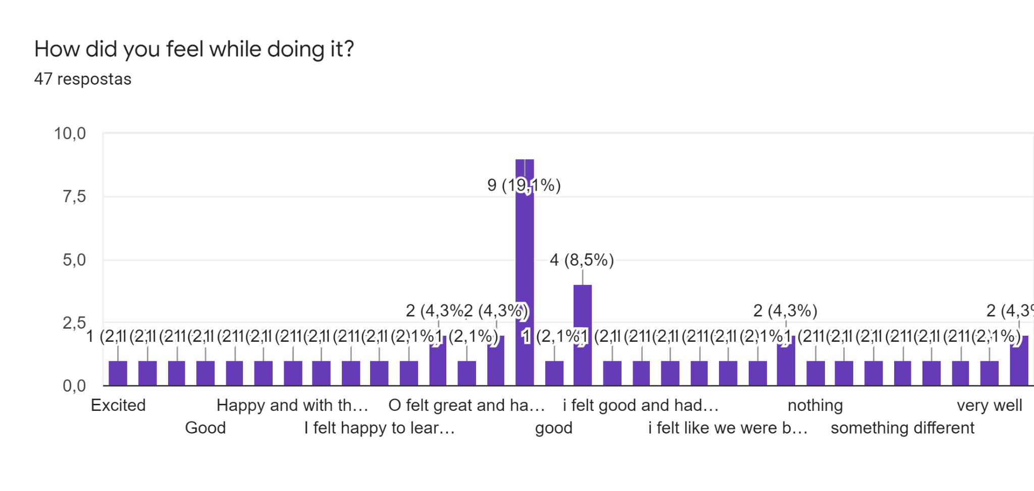

Most of the students felt very good during their favourite activity and especially about being part of this project. Some students were happy to learn something new that will be useful for their future. The other students felt grateful because they were learning about something and wouldn´t have an opportunity to learn in any other way. Finally the students felt anxious to get to know those new students, but also fulfilled because the mobility day had arrived.

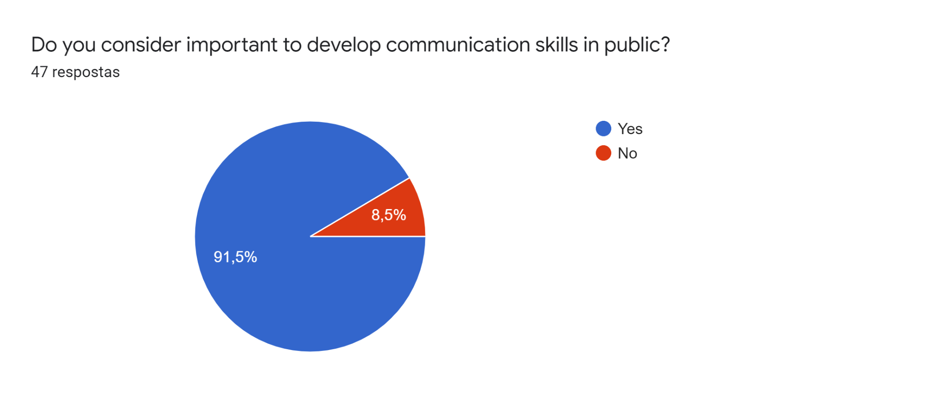

Thirty one students considered the development of communication skills in public very important for this project.

**If you agree, justify your answer.**

All the students who considered important to develop communication skills in public conclude that this is one of the skills they will most need in their future. They are conscious that speaking in public will probably be a “must have” in their future jobs and the possibility of learning how to do it and practicing it in a natural situation will allow them to feel more at ease with the language. Besides, they find it will be an important ability when they enter the job market. In a certain way, with these oral presentations they must be able to express themselves in English and to communicate and pass the correct message, something they imagine themselves doing in some years in a professional situation.

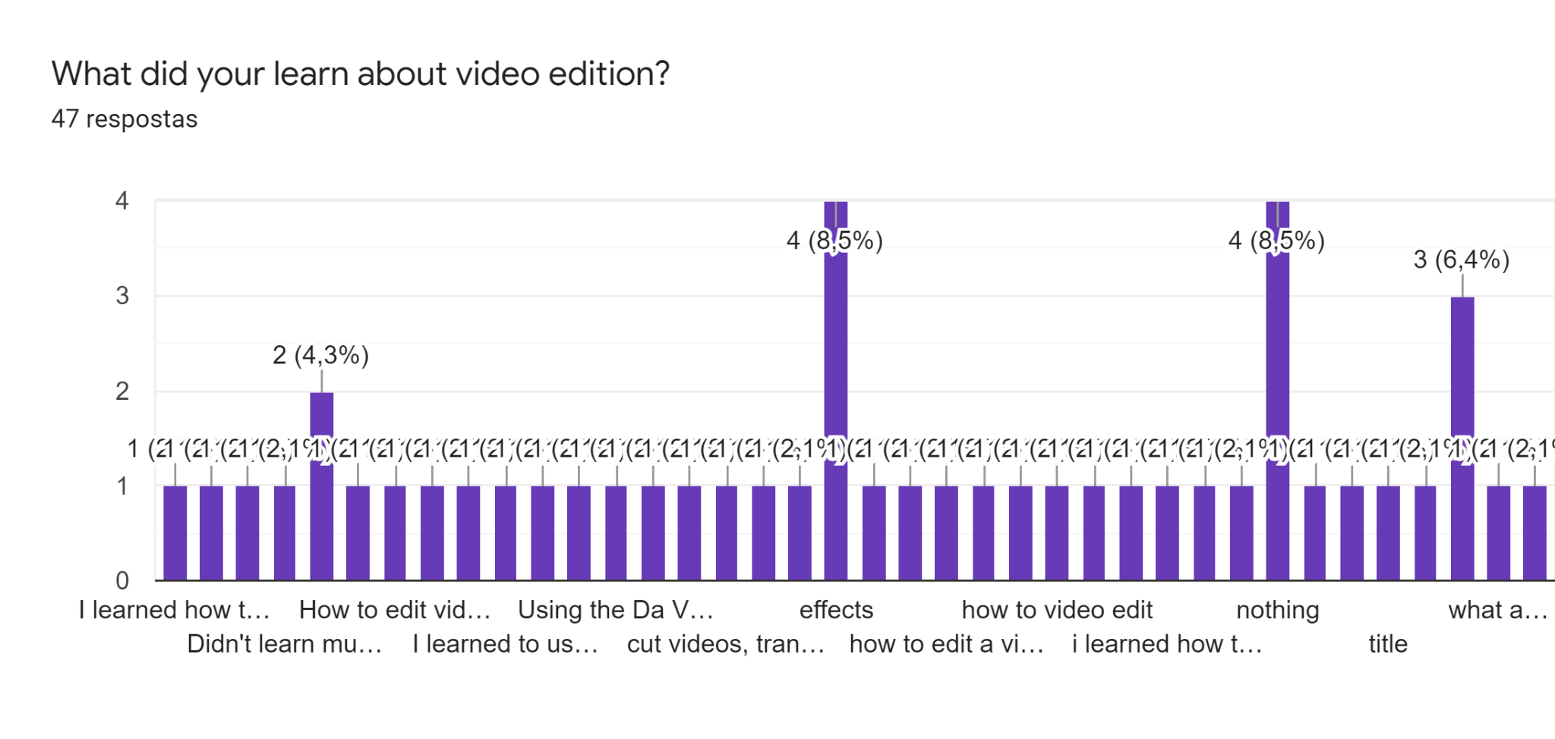

The Students learned different skills with this program. Almost all learned how to edit videos.

The other students learned about:

* Cutting video and putting animation;
* Editing and making dynamic videos and above all what app to use;
* Learning to use apps that they did not know before;
* Working as a team and getting to know how to edit videos more efficiently;
* Cutting videos and making the transitions;
* Using effects;
* Writing on the video;
* Learning a lot of ways to edit videos in a presentable and professional way;
* Doing transitions and making memories last forever in a much funnier way;

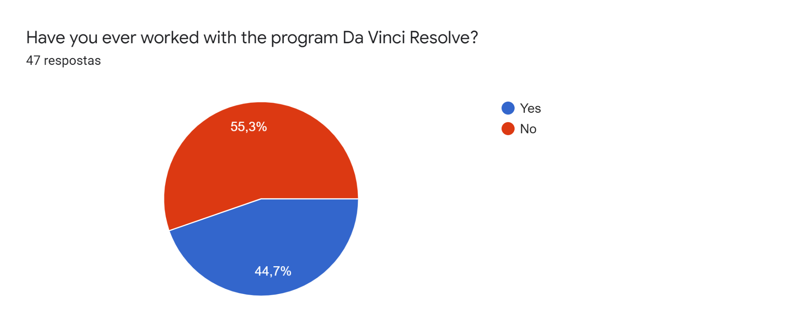

More than half of the students had never worked with the program Da Vinci Resolve. Twenty one students had worked before the mobility with the program.

**What did you learn from this program you didn't know before?**

Almost all students learned something about the Da Vinci Resolve program. Most of them are already able to edit videos in a more professional way with a different kind of form of editing, such as using effects and transitions, adding photos, and cropping videos. Some students report that they can make a short video in an easier way.

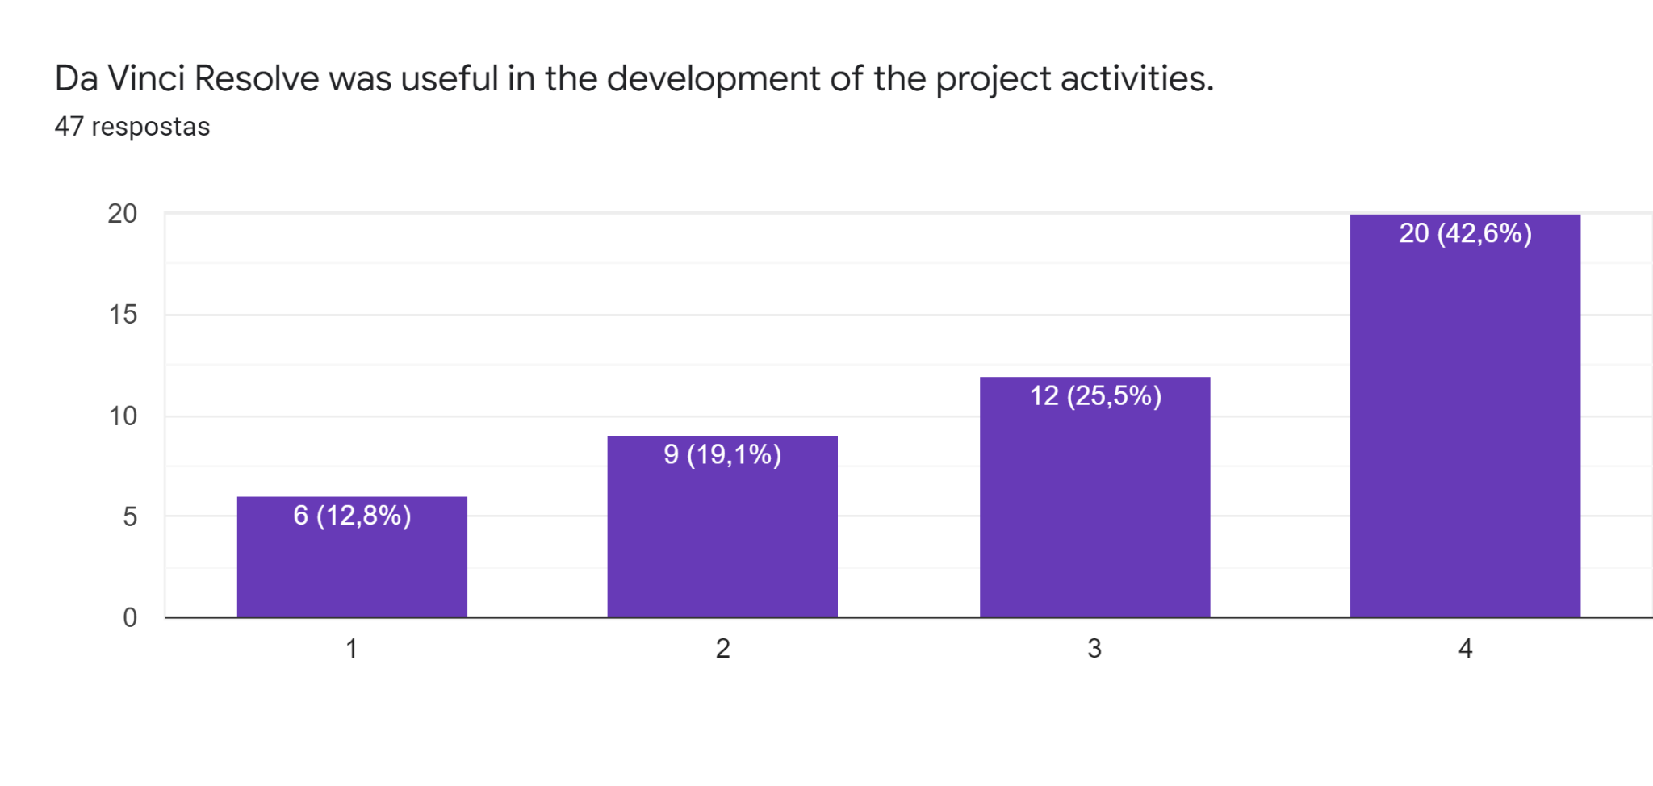

More than half of the students agree that it was useful to use the Da Vinci Resolve program to make the activities about video editing.

**What did you learn about photojournalism ?**

The students learned how to take a professional photo with cadrage, right position. The expert taught them the golden rules of photography. Furthermore students now know how to print life on the picture. Some students feel they are able to take better pictures in a professional way and edit them.