Photography

**Speed**

Divisions of 1 second

>1/60 - minimum when something is moving

<1/250 - minimum when something is moving fast

**AV - Aperture**

Speed automatic (you just have to control the value in the eyescreen, to be sure it respect the recommandation from the speed chapter)

Let’s start with F/3.5. The lens has to be 18mm to be closer, don’t zoom if you can.

F/3.5 - the widest

F/8

F/11- the closest. You don’t need to use a closer value.

**ISO**

the Sensibility

100 iso - less value, no noise

200

300

400…

1600 and more, many noise, take care of it.

**Exemple of values**

Encuadre with the same light

1/50 - F/4 - 800

1/50 - F/8 - 3200

1/100 - F/4 - 1600

1/100 - F/8 - 6400

You have to find the good one, to choose more (or less) depth of field, not too much noise, a good speed to not make blur pictures.

Remenber again :

More Iso - more noise

More aperture - more depth of field

Speed - to avoid it being blurred

**FRAME**

The golden rule: number phi – The snail

Remember : your subject won’t be in the middle, always on a third point.

(Points: Who, what, where, when, why, how)

**The Pictures for the exhibition have to be always horizontal and in a ratio of 2:3**

**Portrait:**

- looking to the right: remembering the past: Melancholty

- Looking to the left: thinking about the future: not so sad

We have to ask the model to look on either side as it has a meaning

**PHOTOJOURNALISM**

Who

What

Where

When

How

1. Iso + aperture + speed (up to 60)
2. Frame
3. 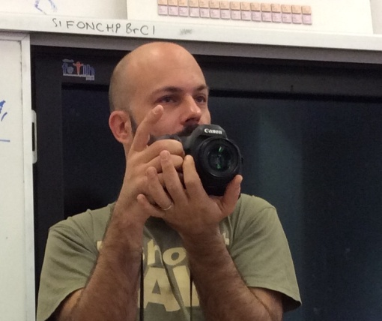Always take care of the background

**Holding the camera**

Like on a plate…

**Raw format**

* more information
* The size of the picture is the size of the sensor