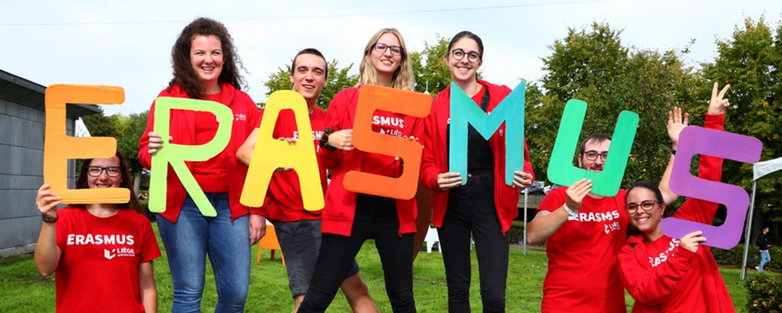

ECSE Eramus +

MARILLAC 21/23

**Step : Choice of Association**

|  |  |  |
| --- | --- | --- |
| As part of your masterpiece for the baccalaureate, this step involves choosing an association to which our company will donate its profits!  You will work in pairs.  Your work will be assessed in three ways :   1. **Your investment in this stage;** From now on your grade starts at 20. Between now and the start in Istanbul, your mark will drop every time you are distracted or talkative for no reason! Choose your partner well in order to do an efficient work and to bring you to a 20 !   You will start by looking for an association that meets the following criteria  a) Local Association ;  b) An association that is properly registered under the 1901 law ;  You will do your research on the Internet.  The final choice of the association will be made in two steps :   * - The best work chosen by the 1PVEN class group (vote in class); * - Then a confrontation with the 1PCOM group * - And a final choice will be made between the two projects to go and present it in Istanbul. (English version)   **DURATION: 40 minutes (Monday 2022/14/03)**  **2) Make a PowerPoint in French and English ;**  The number of slides is free BUT the following information must beincluded **:**  a) The name and photo(s), logo of the association ;  b) The presentation of the association at work :  - History ;  - Organisation chart ;  - Purpose ;  - Actions carried out ;  At this stage you can either find all the information on the Internet or you can contact the association to get the information. In this case MAKE A CROC and KEEP IT ! It will be in your PERSONAL FOLIO HOLDER !  **DURATION : 3h30 (Monday 2022/14/03 et Tuesday 2022/15/03)**  **3) Preparation for the oral presentation of your project;**  The date is 21 MARCH AFTERNOON for the 1PVEN project selection!  Maximum 10 minutes per group For the choice between the 1PVEN and the 1PCOM the date will be in the same week in the class of a teacher of the masterpiece. The date will be confirmed as soon as possible. | se | La création d'une association loi 1901  Comment minuter ses diapositives sur PowerPoint ?  Comment faire un bon PowerPoint en 3 étapes ? - Les incontournables |

**DURATION : 1h30 (Monday 2022/21/03)**

**THREE MARKS FOR THIS WORK !**